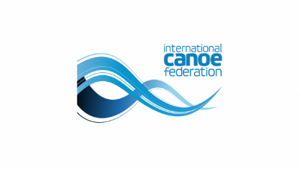
2023 ICF CANOE SPRINT AND PARACANOE WORLD CHAMPIONSHIPS
August 23-27, 2023
Duisburg 2023
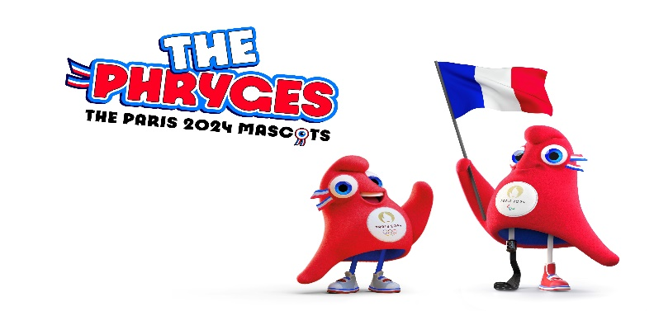
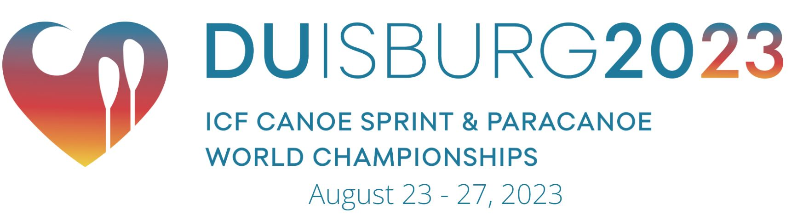
World championships and Paris 2024 qualifiers - media guide
THE VENUE
The regatta course in Duisburg is located at the heart of Sportpark Duisburg, approximately three kilometres from the city centre.
The course is 2180 metres long and between 125 to 135 metres wide. It runs north to south and has a minimum water depth of seven metres.
A parallel 30-metre wide canal runs to the west of the course with links to the main regatta course at 1100 metres and 1800 metres.
THE CITY
Duisburg is a city in Germany's Rhineland, the fifth-largest city in the nation's most populous federal state of North Rhine-Westphalia. Its 500,000 inhabitants make it Germany's 15th largest city.
Located at the confluence of the Rhine river and its tributary the Ruhr river, it lies in the west of the Ruhr urban area, Germany's largest, of which it is the third-largest city after Dortmund and Essen. The Ruhr itself lies within the larger Rhine-Ruhr Metropolitan Region, one of Europe's largest conurbations. The city lies on both sides of the Rhine, with the city centre and most boroughs on the river's right bank, and is the only city of the Rhine-Ruhr region lying on both the Rhine and Ruhr rivers.
Duisburg is one of the largest cities in the Meuse-Rhenish dialect area and the largest in the South Guelderish area.
Duisburg has the world's largest inland port. The city is also renowned for its steel industry.


CANOE SPRINT – A BEGINNER’S GUIDE
In canoe sprint, two types of boats are used: canoe (C) and kayak (K). Canoe sees paddlers compete in a kneeling position using a single-blade paddle. In contrast, a kayak paddler competes in a sitting position using a double-bladed paddle.
Kayak paddlers steer with their feet using a rudder, whereas there is no rudder in a canoe so athletes must use their paddle to steer. As opposed to rowing where boats race backwards, both canoes and kayaks move forwards.
Races take place on a 9m wide flatwater course where boats line up and take off together when the starter signals. The top eight boats from the semi-finals advance to the ‘A’ final, while the boats placing 9th to 16th compete in the ‘B’ final.
The main attraction of canoe sprint is the dynamic and powerful start. Boats go from a still position and dash to top speed in seconds. The shortest distance race is 200m, with the men’s kayak single finishing in about 30 seconds.
The 500m and 1,000m races require strategic pacing and tactical racing against opponents, with the final sprint to the finish line being extremely fierce. Meanwhile, the key to winning the double and four events is the synchronised paddling skills of teams.

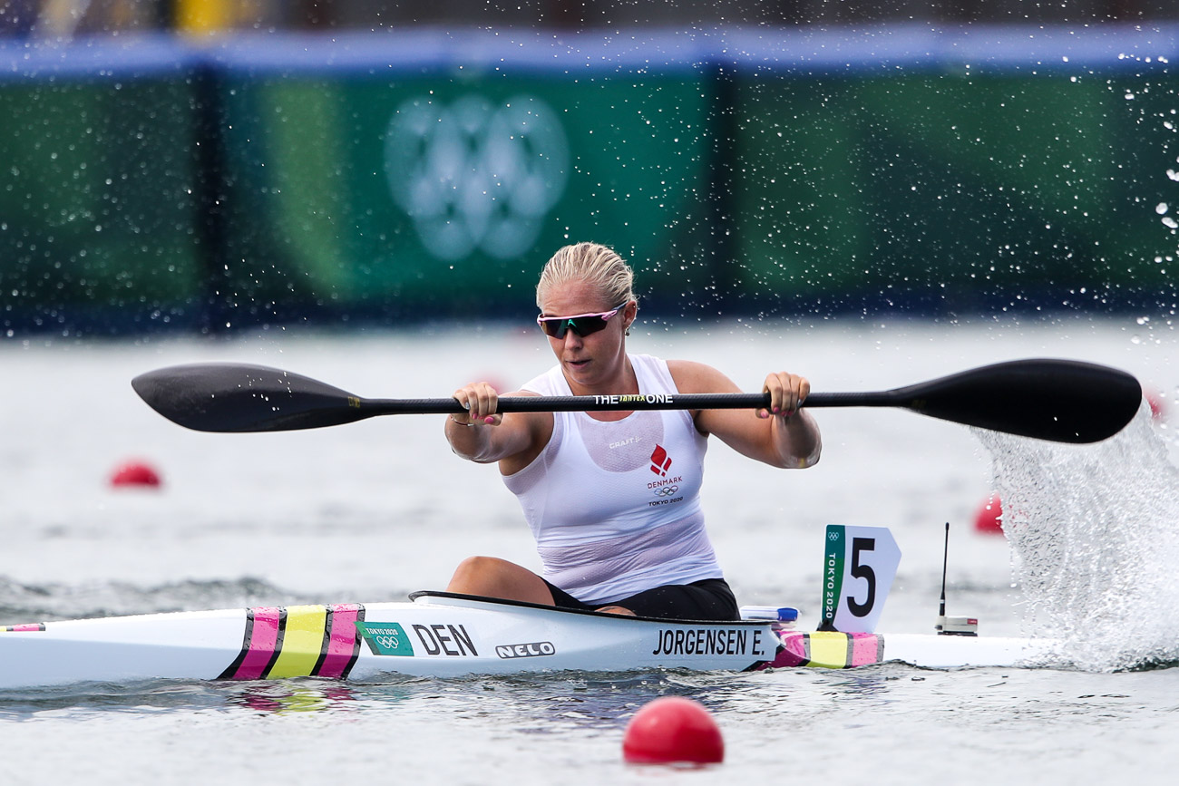
FOR MORE INFORMATION AT THE CHAMPIONSHIPS
ICF Media and Communications Manager Ross Solly
Phone +41 782 413 114 E-mail ross.solly@canoeicf.sport Website canoeicf.com

PARACANOE – A BEGINNER’S GUIDE
Paralympic canoe is exactly like canoeing for able-bodied athletes, enabling those with physical impairments to enjoy the sport and compete at the highest level. Athletes with impairments to the lower body or trunk compete in an individual 200-metre sprint on a straight-line course.

Races are contested by two types of boat, kayak and va'a (which means ‘small boat’ in the Polynesian language). The kayak is propelled by a double-blade paddle, while the va'a is an outrigger canoe which has a second pontoon as a support float and is used with a single-blade paddle.

Paracanoe made its Paralympic debut in Rio in 2016, with six gold medal events. The va’a was introduced in Tokyo.

Para canoeists use upper body strength to drive their boat through the water, combined with an efficient, dynamic and stable paddling technique.

Kayak These boats are ideally shaped for forward motion at 5.2m long, a minimum of 50cm wide and with a minimum weight of 12kg. The paddles are approximately two metres long and have a water-scooping blade on both sides. Athletes use one paddle and advance by placing the blade in the water alternately on each side of the boat.

Va'a This boat is longer than a kayak at up to 7.3m and has a minimum weight of 13kg, its length giving it more forward force. An outrigger (float) is used on either the left or right side of the boat to maintain balance.

Canoes fitted with an outrigger have long been deployed by Pacific Islanders, but their use in sport is new. The paddles used with va'as have a blade on one side only and propulsion is achieved by placing the paddle on one side of the boat. Particular skill is needed to keep moving straight.

Athletes can modify the seat of the canoe and the inside of the cockpit to suit their individual impairment. A range of devices are used to maintain posture and ensure the athlete is stable and secure within the boat, such as belts to fix the body into the seat.

Classification

Athletes are divided into three groups according to degree of impairment and activity limitation. The classes are KL1 (athletes who have very limited trunk and no leg function and paddle with shoulders and arms only); KL2 (athletes who are partially able to use their legs and trunk); and KL3 (athletes have trunk and partial leg function. They are able to sit with their trunk bent forward in the kayak and are able to paddle by bracing their legs and using their hips).
DUISBURG 2023 RACES
(Check website for race schedules)
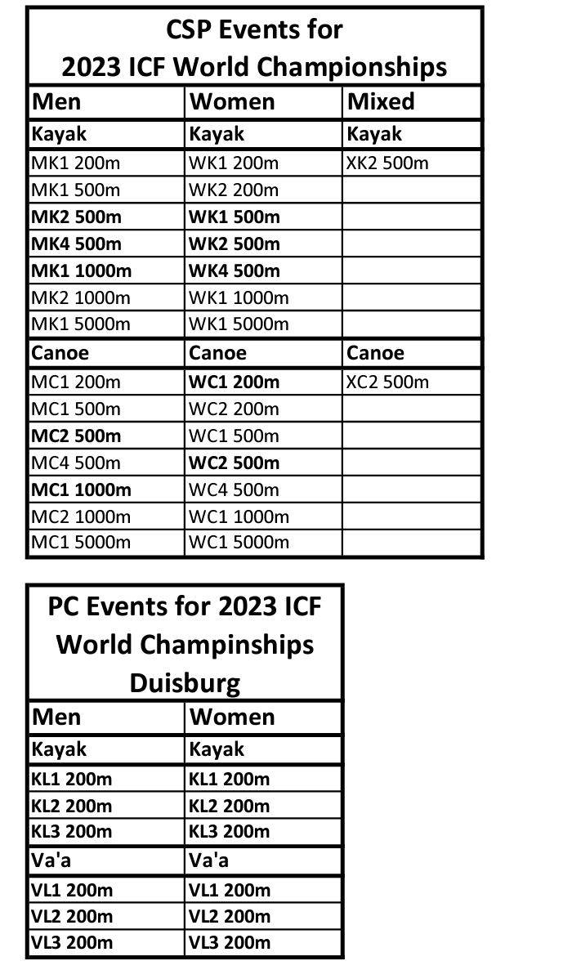
IMPORTANT MEDIA INFORMATION
Only accredited media and photographers will be permitted to enter mixed zones and other areas set aside for working media.
Media can request interviews with athletes straight after a race, by informing boat control officials the lane number they would like called to the dock.
Media are not permitted entry into the team areas, unless accompanied at all times by a team official.
Any questions, please contact ICF Media Manager Ross Solly +41 782 413 114

OLYMPIC AND PARALYMPIC QUOTAS
This week in Duisburg, Germany, close to 1000 paddlers from all round the world will be putting everything on the line, trying to become world champions and earn quotas for their country to compete at next year’s Olympic and Paralympic Games Paris 2024.
So how many quotas are up for grabs, who can win them, and is this the last chance saloon?
Firstly, the number of Paris slots available is different for each event.
The most intense racing will take place in the men’s and women’s K4 500, where 10 countries will book their places in Paris. This will be the one and only opportunity to qualify a K4.
There are some important rules to remember. There has to be four continents represented, meaning the first boat to finish from the first four continents, no matter what their overall placing, will be on the way to the Olympics.
Another rule to remember is an athlete can only earn one quota for their country. For example, if Lisa Carrington is a member of the New Zealand women’s K4 which earns a quota next week, she cannot also earn a quota in the K2 or K1.
Each country will be limited to no more than nine athletes per gender for the Olympics – six in kayak, and three in canoe.
So here is the breakdown of quotas available in Duisburg next week;
K4 500 men – 10 boats
K4 500 women – 10 boats.
K2 500 men – six boats
K2 500 women – six boats
K1 1000 men – six boats
K1 500 women – six boats
C1 1000 men – five boats
C1 200 women – five boats
C2 500 men – eight boats
C2 500 women – eight boats
The breakdown of quota spots available for the Paralympics is much more straightforward. In every event which is on the Paris 2024 calendar the top six finishes will earn quotas in Duisburg. But only one athlete per country can earn a ticket.
Will this be the last chance to earn Olympic and Paralympic quotas?
No. With the exception of the K4 500, additional quotas will be available at continental championships to be held later this year and early next year.
Similarly in paracanoe, additional quotas will be available at next year’s ICF Paracanoe World Championships.
ATHLETES TO WATCH – OLYMPIC EVENTS
WOMEN’S K1 500
CARRINGTON, Lisa (NZL) – Reigning Olympic champion and world champion from 2022, also won the title in 2015 and 2019.
CSIPES, Tamara (HUN) – Olympic silver medalist behind Carrington.
JORGENSEN, Emma (DEN) – Bronze medalist from Tokyo, silver medal in Rio. Current European champion.
GOVORCINOVIC, Anamaria (CRO) – Reigning world championship silver medalist, fourth at European Championships.
NOVAKOVIC, Milica (SRB) – Third at this year’s European titles.
MEN’S K1 1000
VARGA, Adam (HUN) – Silver medalist in Tokyo, unbeaten at world cups this year. Also won men’s K1 500 European title.
PIMENTA, Fernando (POR) – Bronze medalist from Tokyo Olympics. Reigning world championship silver medalist.
DOSTAL, Josef (CZE) – Silver medalist in Rio in 2016, fifth in Tokyo and fifth at most recent world championships.
GREEN, Tom (AUS) – Seventh at Tokyo Olympics, fourth at recent world championships.
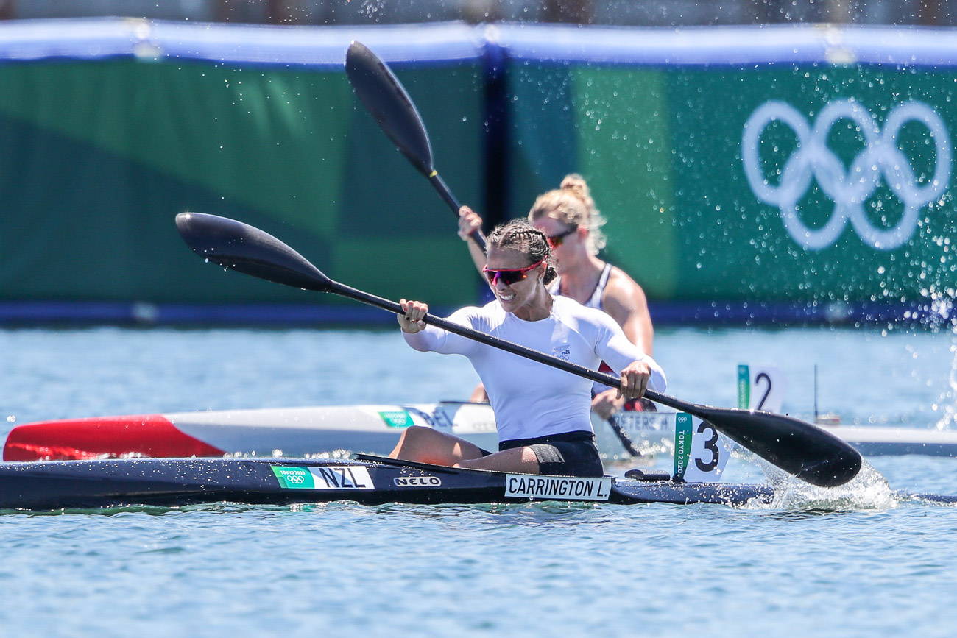
WOMEN’S K2 500
FISHER/MCKENZIE (NZL) – The combination of a former sprint world champion and an ocean racing world champion will be interesting to watch.
KLATT/WISNIEWSKA (POL) – Beat their more fancied teammates at the world cup in Poznan and have been paddling strongly together.
PASZEK/HAKE (GER) – Silver medalists from recent world championships. Fourth at the Europeans and fourth in Poznan.
PETERS.BROEKX (BEL) – Experienced pairing, finished third at recent world championships and sixth at Europeans.
JORGENSEN/MATTHIESEN (DEN) – New pairing, won silver at European titles.

MEN’S K2 500 (new Olympic event)
FRANK/HILLER (GER) – Second at European titles, second Poznan world cup.
SPICAR/HAVEL (CZE) – Fourth at world championships.
NADAS/KOPASZ (HUN) – Reigning world champions.
MALDONIS/OLIJNIK (LTU) – World championship silver medalists. Fifth at Europeans.
HOLPERT/DRAGOSAVLJEVIC (SRB) – Third at European titles.
VAN DER WESTHUYZEN/GREEN (AUS) – Reigning K2 1000 Olympic gold medalists. Third at world championships

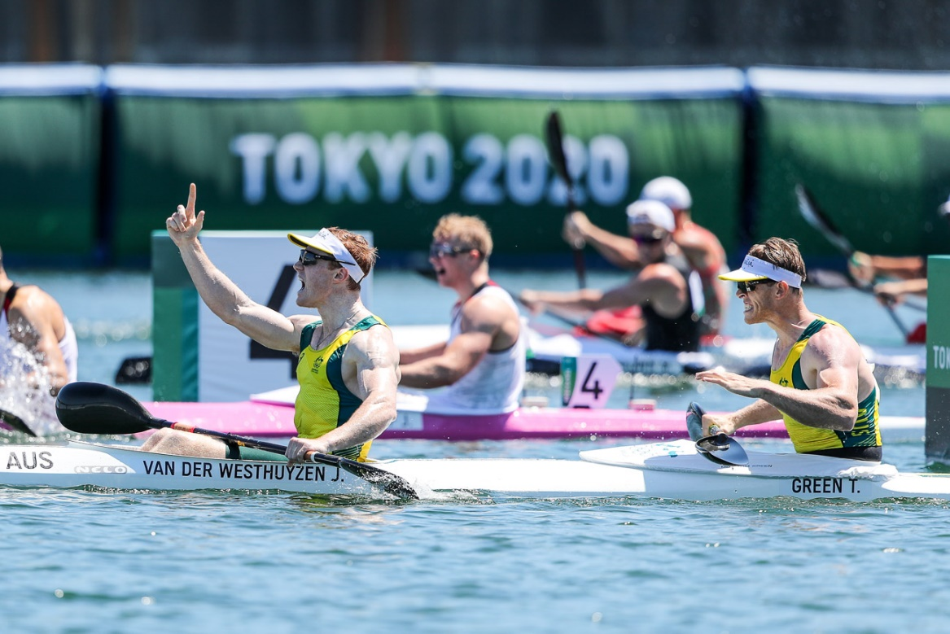
WOMEN’S K4 500
POLAND – Reigning world champions, third at the Tokyo Olympics.
NEW ZEALAND – Fourth in Tokyo, but changed crew since. Finished fifth at world championships.
GERMANY – Finished fifth in Tokyo, and hasn’t won a world championship medal since 2017. Did finish second at European titles
SPAIN – Finished fourth at world championships.
MEXICO – Third at world championships.
DENMARK – Third at European titles.
CHINA – Won world cup in Szeged and second in Poznan.
HUNGARY – Has won the past three Olympic gold medals. But finished off the podium for the first time since 1983 at recent world championships.
AUSTRALIA – Second at world championships.
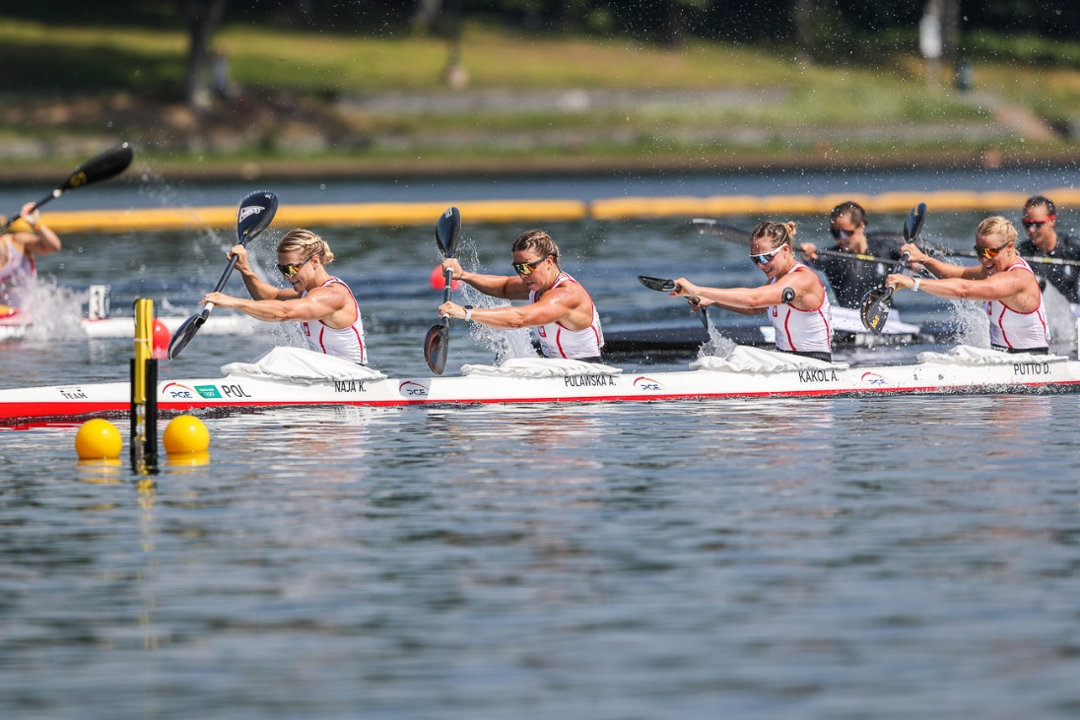
MEN’S K4 500
SPAIN – Reigning world and European champions, Olympic silver medalists.
GERMANY – Reigning Olympic champions and world championship silver medalists.
UKRAINE – Third at world championships, second at Europeans.
LITHUANIA – Surprised with world cup win in Szeged.
SLOVAKIA – Bronze medal in Tokyo, fourth at world championships.

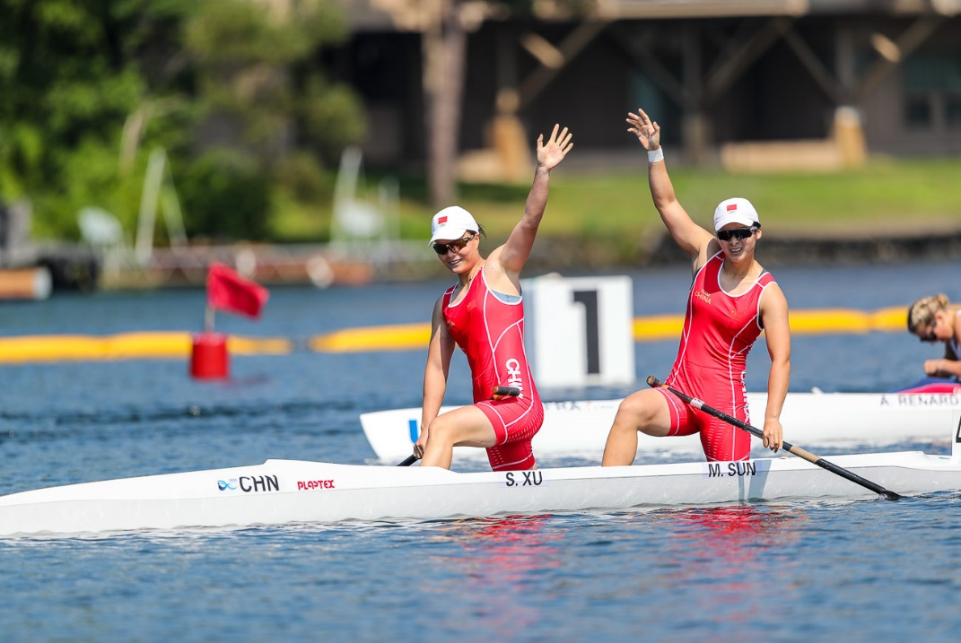
WOMEN’S C2 500
CHINA – The pairing of Shixiao Xu and Mengya Sun have been unbeatable since they won gold at the Tokyo Olympics.
CANADA – The experienced Katie Vincent pairing up with Sloan MacKenzie for an event the Canadians have traditionally performed well in.
HUNGARY – Giada Bragato and Biank Nagy won bronze at the last world championships and are much improved..
UKRAINE – Liudmyla Luzan was one of the stars of Tokyo and has teamed up with Vakleriia Tereta for the event in which she won silver at the Olympics.
CUBA – Have been consistent performers since Tokyo.
SPAIN – Antia Jacome and Maria Corbera have both shown a lot of speed individually.
MOLDOVA – Daniela Cociu and Maria Olarasu are two of the more experienced canoe paddlers.

WOMEN’S C1 200
HARRISON, Nevin (USA) – The sport’s first ever Olympic gold medalist, also a two-time world champion. Has not been seen much in 2023.
LUZAN, LIUDMYLA (UKR) – Bronze medalist in Tokyo, world champion over 500 metres.
JENSEN, SOPHIA (CAN) – Exciting young paddler who dominated at a junior level.
LIN, WENJUN (CHN) – Bronze at last world championships.
BOROWSKA, DOROTA (POL) – Fourth at Tokyo Olympics.
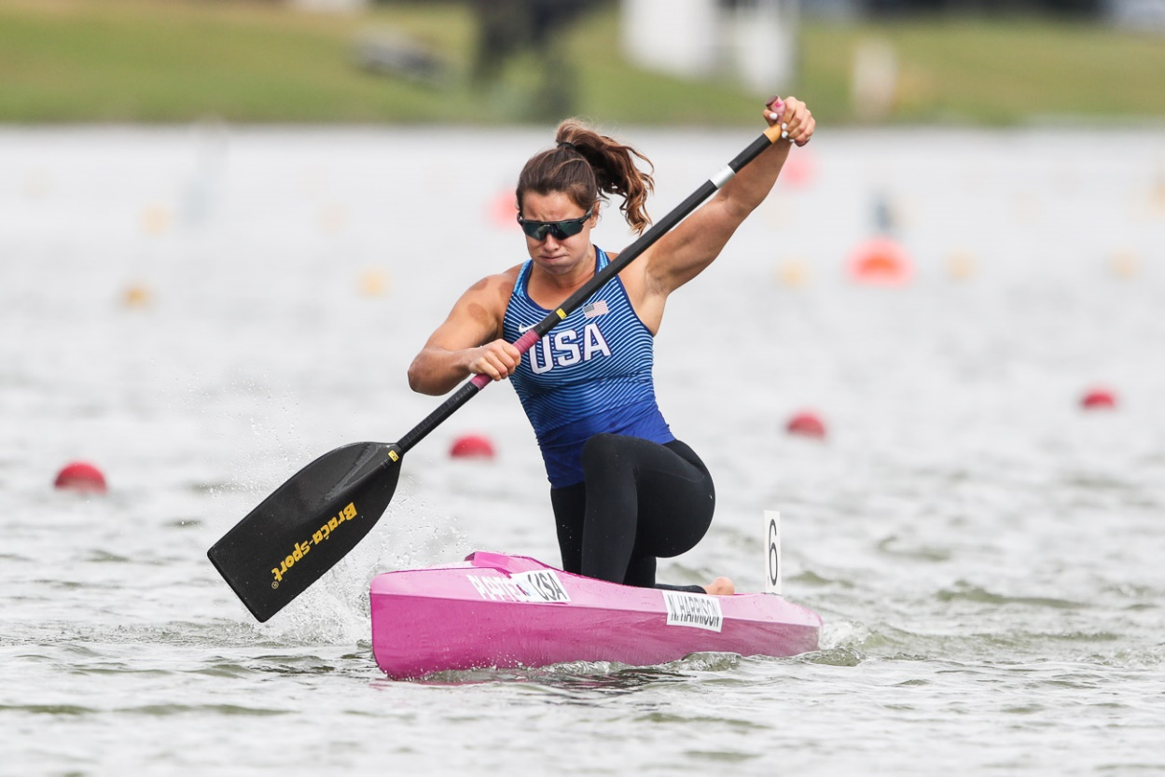
MEN’S C1 1000
BART, Adrien (FRA) – Fourth place Tokyo Olympics. Third 2019 world championships.
TARNOVSCHI, Serghei (MDA) – Tokyo Olympic bronze medalist.
FUKSA, Martin (CZE) – Fifth place at Tokyo Olympics. World championships silver medalist, behind Germany’s Sebastian Brendel each time, in 2018, 2017, 2015, 2014.
BRENDEL, Sebastian (GER) – Two-time Olympic gold medalist, 2012/2016
QUEIROZ, Isaquias (BRA) – Gold medalist from Tokyo, silver medalist from Rio.
CHIRILA, Catalin (ROU) – Reigning world champion

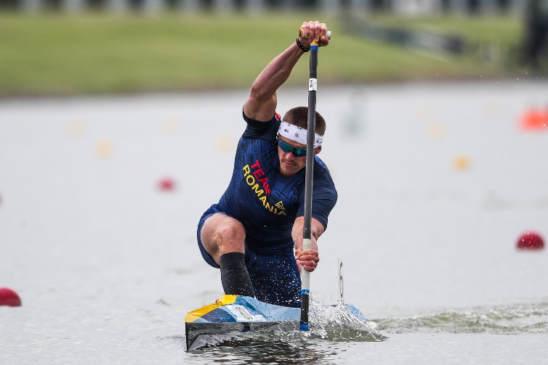
MEN’S C2 500
SPAIN – Garcia and Martinez won the world title and finished second at the Europeans.
BRAZIL – Isaquias and Godmann finished fourth in the C2 1000 in Tokyo..
CHINA – Liu and Ji finished third at recent world championships. Liu was also in boat that finished second in C2 1000 at Tokyo.
ITALY – Casadei and Tacchini won at Poznan world cup and then won this year’s European title.
POLAND – Kitewski and Zezula won silver at European titles..
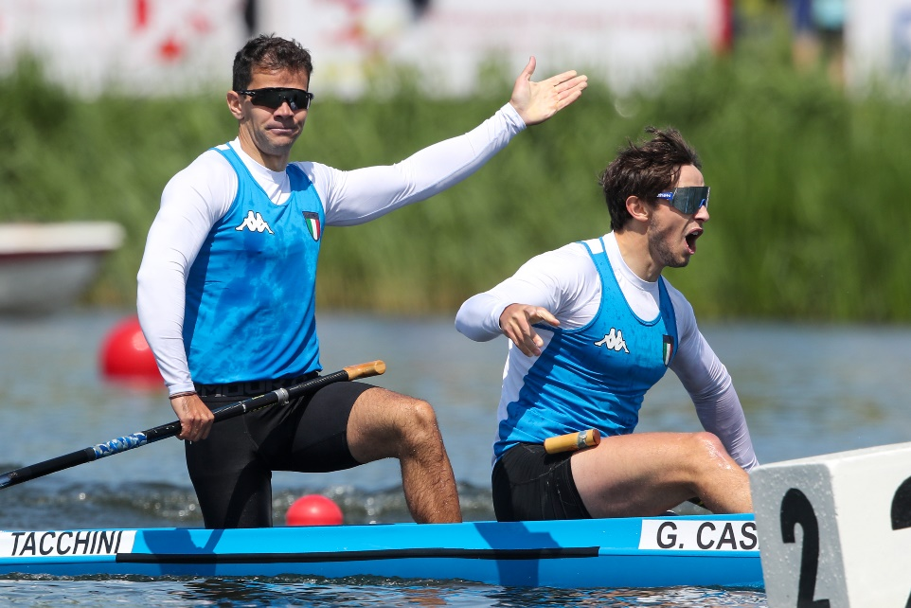

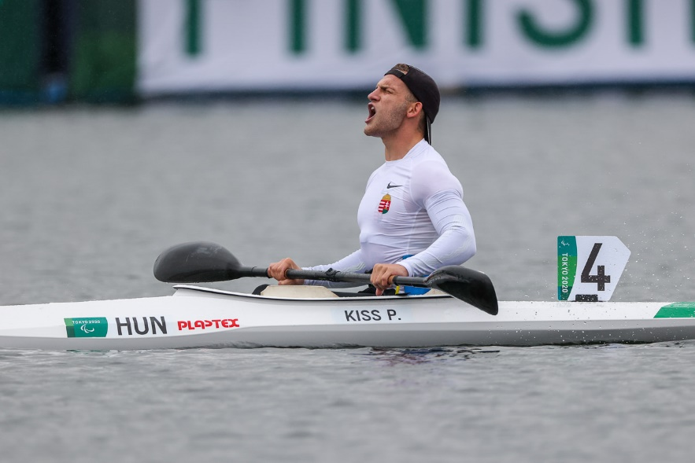
ATHLETES TO WATCH – PARACANOE (Paralympic events)
MEN’S KL1 200
KISS, Peter Pal (HUN) – Tokyo 2020 Paralympic gold medalist. Reigning ICF world champion, the youngest Paracanoe competitor in Tokyo. Is also the reigning European champion.
Da SILVA, Luis Cardoso (BRA) – Silver medalist in Tokyo. Bronze medalist at the 2016, 2017, 2018 and 2019 world championships, silver in 2022.
BOULLE, Remy (FRA) – Bronze medalist in Tokyo and at 2022 world championships.

WOMEN’S KL1 200
MULLER, Edina (GER) – Gold medalist from Tokyo. Gold medalist in women’s wheelchair basketball at the London 2021 Paralympics, won paracanoe silver in Rio after becoming world champion in 2016. Silver medalist 2019 world championships.
MAZHULA, Maryna (UKR) – Silver medalist Tokyo, world champion 2018, 2019, 2022.
WOLLERMANN,Katherinne (CHI) – Bronze medalist in Tokyo.
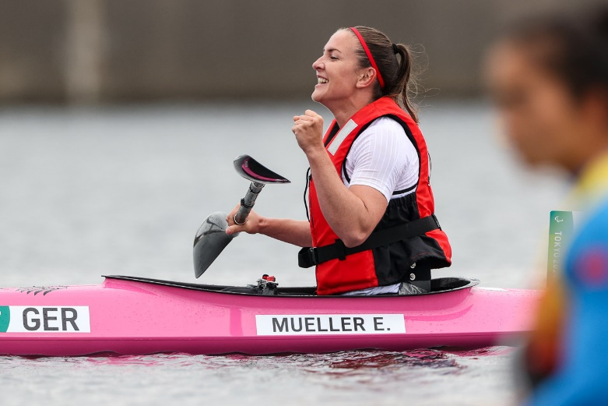
MEN’S KL2 200
SYNIUK, Mykola (UKR) – Silver medalist in Tokyo, 2022 world champion, fourth Rio Paralympics
MANCARELLA, Federico (ITA) – Bronze medal winner in Tokyo, second at 2019 world championships.
MCGRATH, Curtis (AUS) – Three-time Paralympic gold medalist and multiple world champion
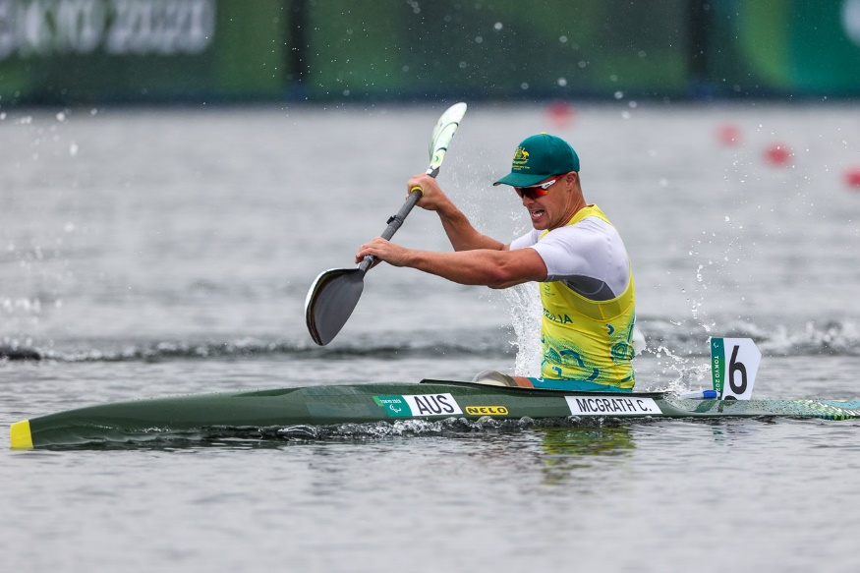
WOMEN’S KL2 200
HENSHAW, Charlotte (GBR) – Tokyo Paralympic gold medalist, multiple world champion.
WIGGS, Emma (GBR) – Silver medalist at Tokyo Paralympics. Gold medalist 2016 Paralympics. World champion 2016 and 2017, world championship silver medalist 2018, 2019, 2022.
VARGA, Katalin (HUN) – Bronze medalist in Tokyo.
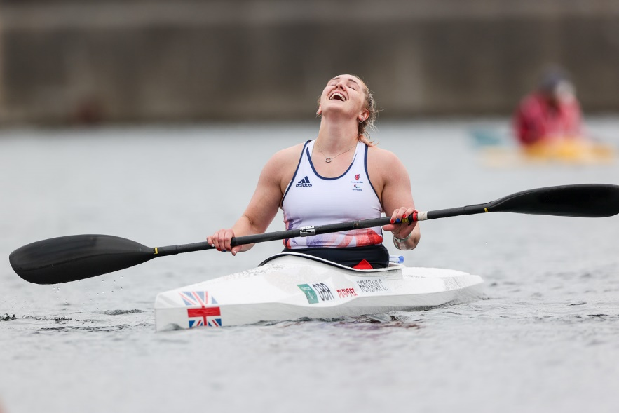
MEN’S KL3 200
VALLE, Juan (ESP) – Reigning world champion.
LITTLEHALES, Dylan (AUS) – World Championships bronze medalist.
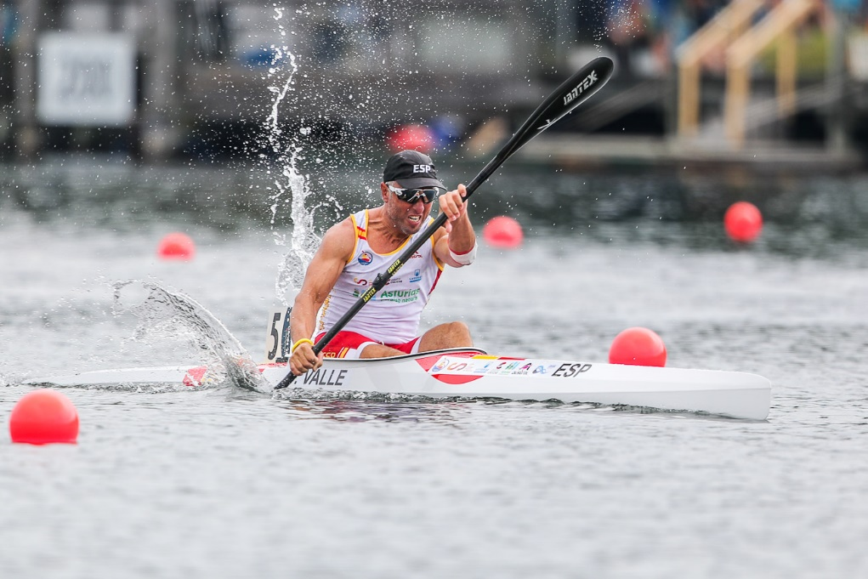

WOMEN’S KL3 200
SUGAR, Laura (GBR) – Tokyo Paralympic gold medalist. World championship gold 2022, silver medalist 2019
BARBOSA, Nelia (FRA) – Tokyo Paralympic silver medalist. Reigning world championships silver medalist.
LABERER, Felicia (GER) – Tokyo Paralympic bronze medalist. World championship bronze medalist.
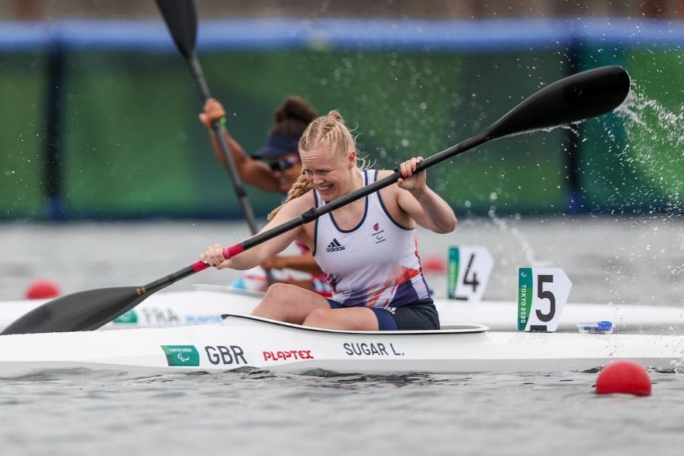

MEN’S VL2 200
RUFINO, Fernando (BRA) – Tokyo Paralympic gold medalist, world championship silver medalist.
TOFALINO, Igor (BRA) – 2022 ICF world champion.
MOURAO, Norberto (POR) – Tokyo Paralympic bronze medalist, world championships bronze medalist. Portugal’s first paracanoe Paralympic athlete.
HAXTON, Blake (USA) – Tokyo Paralympic silver medalist.
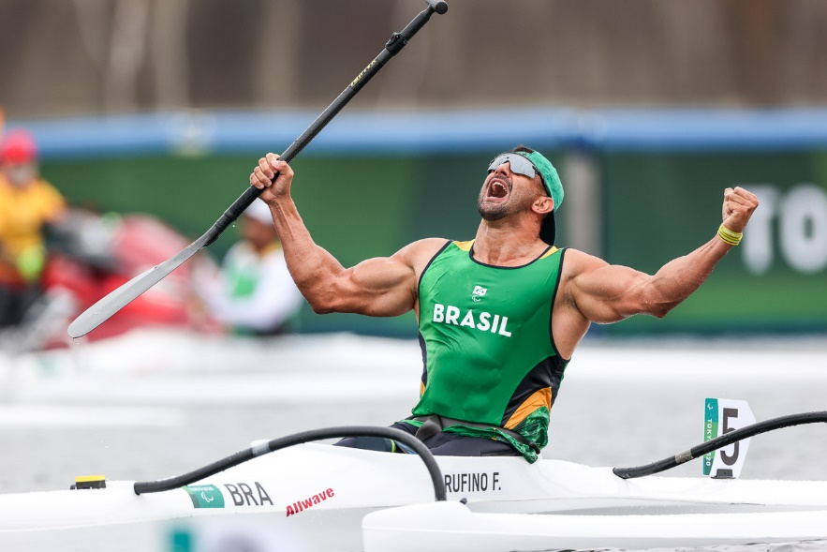
MEN’S VL3 200
VIERA, Giovane (BRA) – Silver medalist Tokyo Paralympics.
MCGRATH, Curtis (AUS) – Reigning Paralympic gold medalist.
WOOD, Stuart (GBR) – Third at the Tokyo Paralympics.
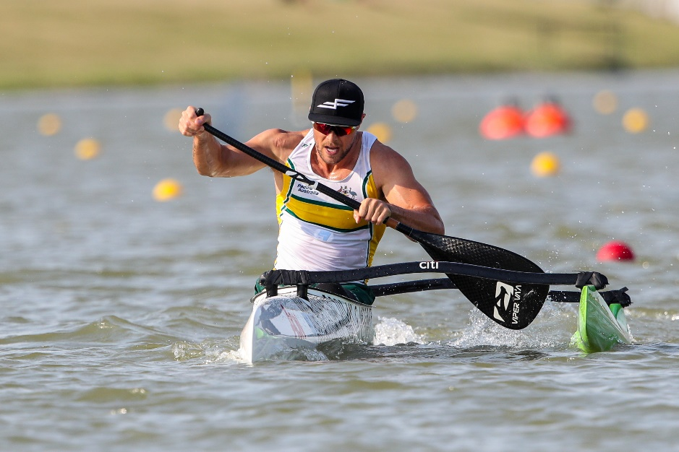
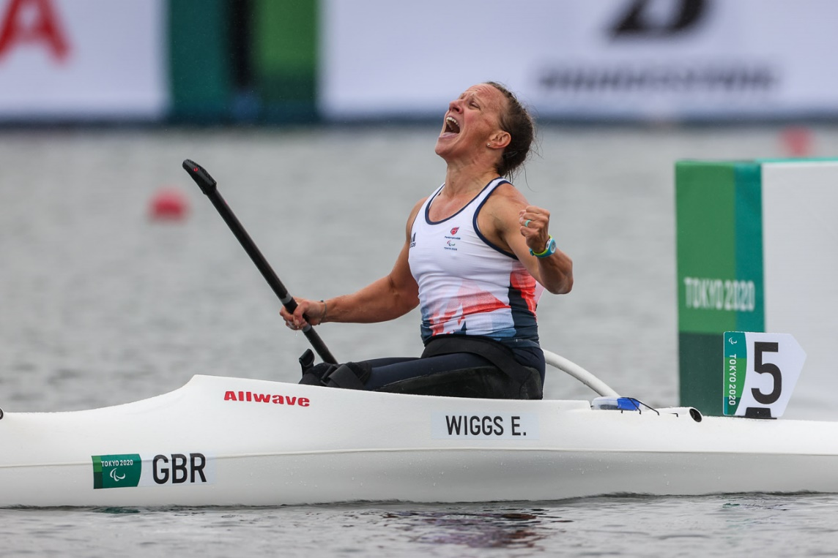

WOMEN’S VL2 200
WIGGS, Emma (GBR) – Tokyo Paralympic gold medalist. World champion 2018, 2019, 2022.
CHIPPINGTON, Jeanette (GBR) – Tokyo Paralympic and world championship bronze medalist.
HENNESSY, Brianna (CAN) – World championship silver medalist.
WOMEN’S VL3 200 (Debut Paralympic event)
GORDON, Hope (GBR) – World championship silver medalist.
SANTILLI, Mari (BRA) – World championship bronze medalist.
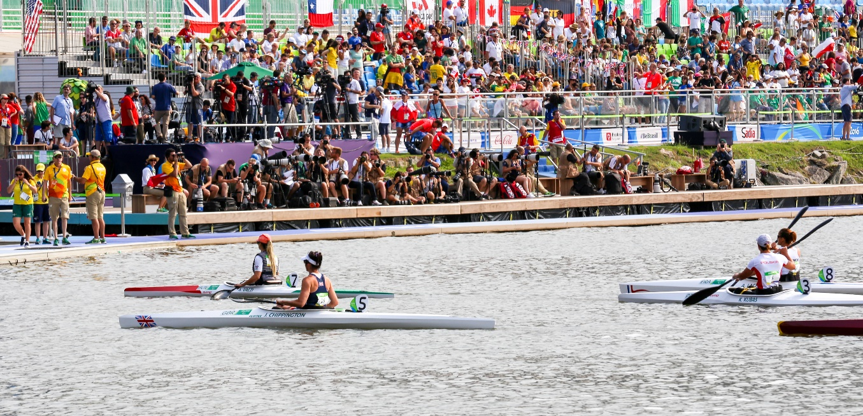
WORLD CHAMPIONSHIPS IN CANOE SPRINT
The world championships have taken place every non-Olympic year since 1970, and have officially included paracanoe events since 2010. 2021 was the first time an ICF canoe sprint world championships was held in the same year as the Olympics, because of the postponement of the Tokyo Games.
Since 2012 there have been ICF Paracanoe World Championships in Olympic and non-Olympic years.
The first canoe sprint world championships were held in Vaxholm, Sweden, in 1938. There were 12 events contested. In Szeged in 2019 there were 30 events in canoe sprint and 12 in paracanoe.
Duisburg will be the 47th ICF canoe sprint world championships, and the sixth time the German city has hosted this event. (2013, 2007, 1995, 1987, 1979).
Hungary has been the most successful nation at the ICF canoe sprint world championships, winning 544 medals (226 gold, 167 silver, 151 bronze). Germany has 327 medals, of which 138 have been gold. In total 55 nations have won ICF canoe sprint world championship medals.
Great Britain has been the most successful nation at ICF paracanoe world championships, winning 81 medals (40 gold, 27 silver and 14 bronze). Brazil has 45 medals, of which 18 are gold. 28 nations have won paracanoe world championship medals.

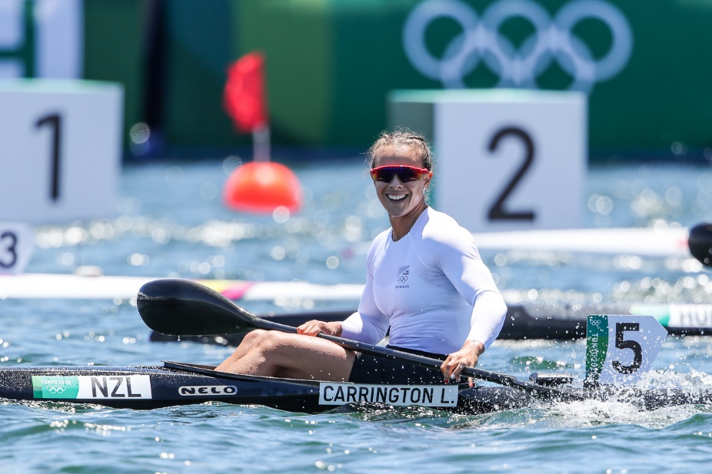

WOMEN’S K1 500 – RECENT OLYMPIC MEDALISTS
2020 – TOKYO, JAPAN
Gold – CARRINGTON Lisa (NZL)
Silver – CSIPES Tamara (HUN)
Bronze – JORGENSEN Emma (DEN)

2016 – RIO, BRAZIL
Gold – KOZAK Danuta (HUN)
Silver – JORGENSEN Emma (DEN)
Bronze – CARRINGTON Lisa (NZL)

2012 – LONDON, GREAT BRITAIN
Gold – KOZAK Danuta (HUN)
Silver – OSIPENKO-RODOMSKA Inna (UKR)
Bronze – HARTLEY Bridgitte (RSA)

2008 – BEIJING, CHINA
Gold – OSIPENKO-RODOMSKA Inna (UKR)
Silver – IDEM Josefa (ITA)
Bronze – WAGNER-AUGUSTIN Katrin (GER)

2004 – ATHENS, GREECE
Gold – JANIC Natasa (HUN)
Silver – IDEM Josefa (ITA)
Bronze – BRUNET Caroline (CAN)

MEN’S K1 1000 – RECENT OLYMPIC MEDALISTS
2020 – TOKYO, JAPAN
Gold – KOPASZ Balint (HUN)
Silver – VARGA Adam (HUN)
Bronze – PIMENTA Fernando (POR)

2016 – RIO, BRAZIL
Gold – WALZ Marcus (ESP)
Silver – DOSTAL Josef (CZE)
Bronze – ANOSHKIN Roman (RUS)

2012 – LONDON, GREAT BRITAIN
Gold – LARSEN Eirik Veraas (NOR)
Silver – VAN KOEVERDEN Adam (CAN)
Bronze – HOFF Max (GER)

2008 – BEIJING, CHINA
Gold – BRABANTS Tim (GBR)
Silver – LARSEN Eirik Veraas (NOR)
Bronze – WALLACE Kenny (AUS)

MEN’S K2 1000 – RECENT OLYMPIC MEDALISTS (changing to 500 in Paris)
2020 – TOKYO, JAPAN
Gold – GREEN/VAN DER WESTHUYZEN (AUS)
Silver – HOFF/SCHOPF (GER)
Bronze – DOSTAL/SLOUF (CZE)

2016 – RIO, BRAZIL
Gold – RENDSCHMIDT/GROSS (GER)
Silver – TOMICEVIC/ZORIC (SRB)
Bronze – WALLACE/TAME (AUS)

2012 – LONDON, GREAT BRITAIN
Gold – DOMBI/KOKENY (HUN)
Silver – PIMENTA/SILVA (POR)
Bronze – HOLLSTEIN/IHLE (GER)

2008 – BEIJING, CHINA
Gold – HOLLSTEIN/IHLE (GER)
Silver – KNUDSEN/POULSEN (DEN)
Bronze – FACCHIN/SCADUTO (ITA)

Bronze – SPICAR/HAVEL (CZE)

2015 – MILAN, ITALY
Gold – RENDSCHMIDT/GROSS (GER)
WOMEN’S K2 500 – RECENT OLYMPIC MEDALISTS
2020 – TOKYO, JAPAN
Gold – CARRINGTON/REGAL (NZL)
Silver – NAJA/PULAWSKA (POL)
Bronze – BODONYI/KOZAK (HUN)

2016 – RIO, BRAZIL
Gold – SZABO/KOZAK (HUN)
Silver – WEBER/DIETZE (GER)
Bronze – NAJA/MIKOLAJCZYK (POL)

2012 – LONDON, GREAT BRITAIN
Gold – WEBER/DIETZE (GER)
Silver – KOVACS/DOUCHEV JANIC (HUN)
Bronze – NAJA/MIKOLAJCZYK (POL)

2008 – BEIJING, CHINA
Gold – KOVACS/JANIC (HUN)
Silver – MIKOLAJCZYK/KONIECZNA (POL)
Bronze – DELATTRE/VIARD (FRA)

2004 – ATHENS, GREECE
Gold – KOVACS/JANIC (HUN)
Silver – FISCHER/LEONHARDT (GER)
Bronze – KONIECZNA/SOKOLOWSKA-KULESZA (POL)

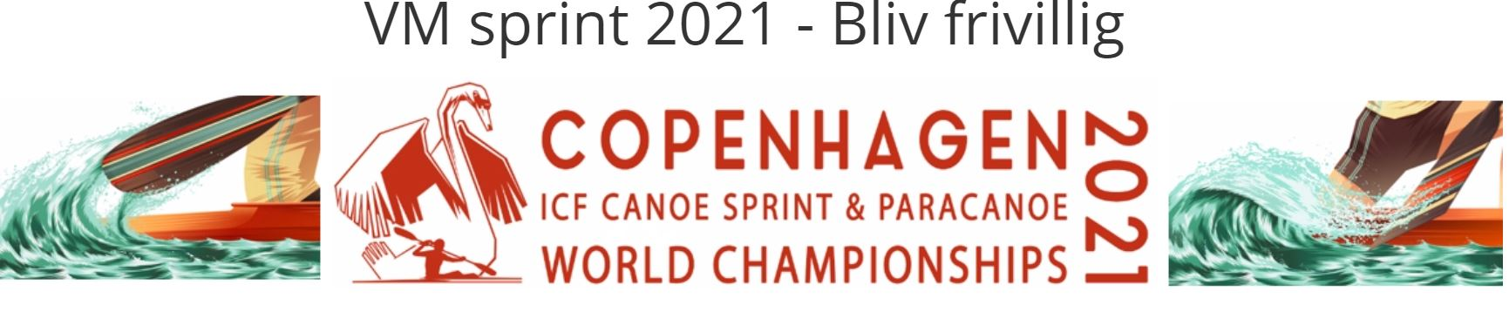
WOMEN’S K4 500 – RECENT OLYMPIC MEDALISTS
2020 – TOKYO, JAPAN
Gold – HUNGARY
Silver – BELARUS
Bronze – POLAND

2016 – RIO, BRAZIL
Gold – HUNGARY
Silver – GERMANY
Bronze – BELARUS

2012 – LONDON, GREAT BRITAIN
Gold – HUNGARY
Silver – GERMANY
Bronze – BELARUS

2008 – BEIJING, CHINA
Gold – GERMANY
Silver – HUNGARY
Bronze – AUSTRALIA

2004 – ATHENS, GREECE
Gold – GERMANY
Silver – HUNGARY
Bronze – UKRAINE

MEN’S K4 500 - TOKYO OLYMPIC RESULT
Gold – GERMANY
Silver – SPAIN
Bronze – SLOVAKIA

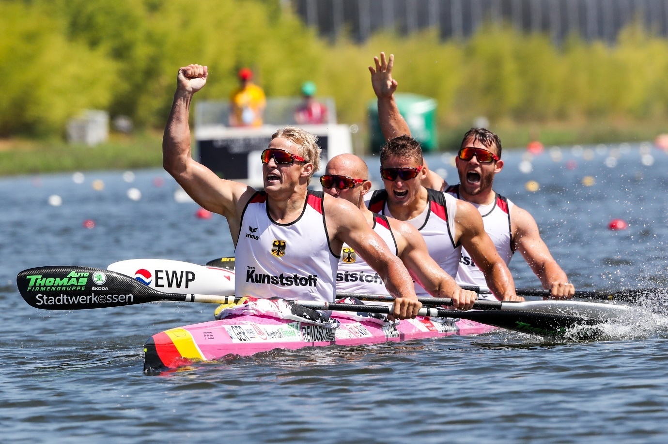

MEN’S C1 1000 – RECENT OLYMPIC MEDALISTS
2020 – TOKYO, JAPAN
Gold – QUIROZ DOS SANTOS Isaquias (BRA)
Silver – LIU Hao (CHN)
Bronze – TARNOVSCHI Serghei (MDA)

2016 – RIO, BRAZIL
Gold – BRENDEL Sebastian (GER)
Silver – QUIROZ DOS SANTOS Isaquias (BRA)
Bronze – SHTOKALOV Ilya (RUS)

2012 – LONDON, GREAT BRITAIN
Gold – BRENDEL Sebastian (GER)
Silver – CAL David Figueroa (ESP)
Bronze – OLDERSHAW Mark (CAN)

2008 – BEIJING, CHINA
Gold – VAJDA Attila (HUN)
Silver – CAL David Figueroa (ESP)
Bronze – HALL Thomas (CAN)

2004 – ATHENS, GREECE
Gold – CAL David Figueroa (ESP)
Silver – DITTMER Andreas (GER)
Bronze – VAJDA Attila (HUN)

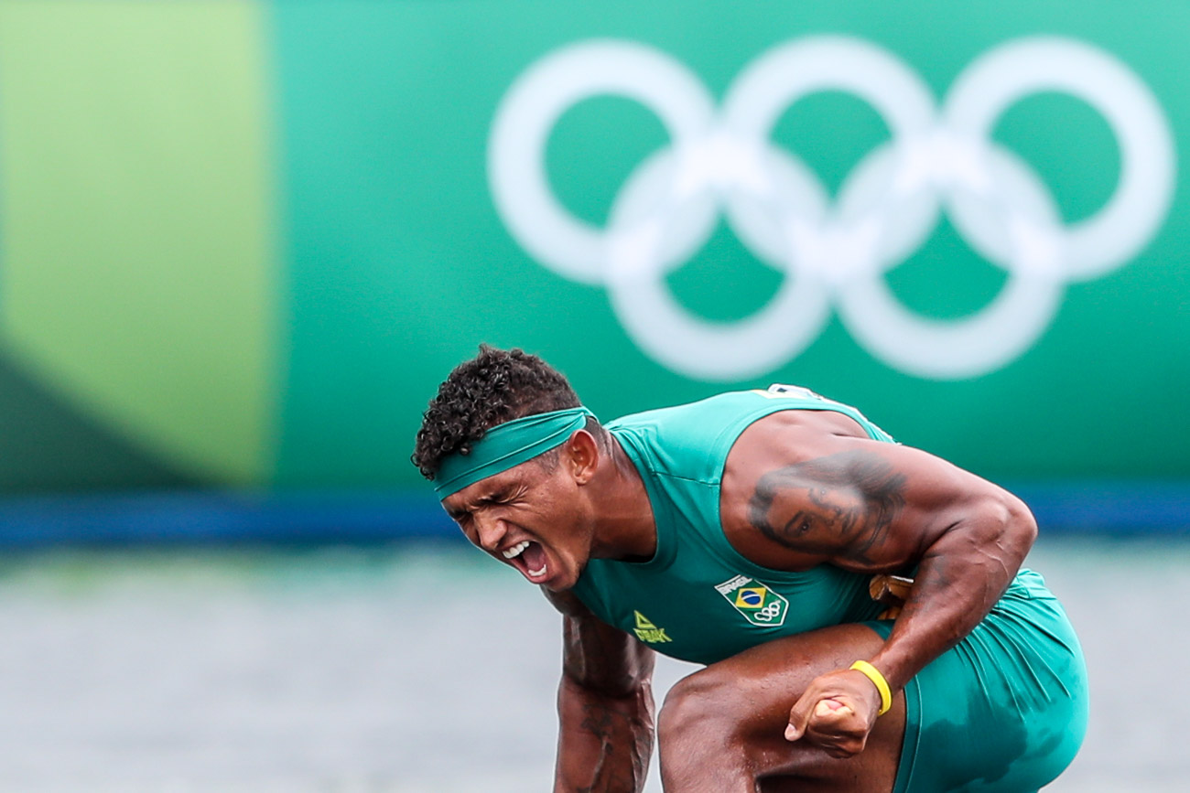
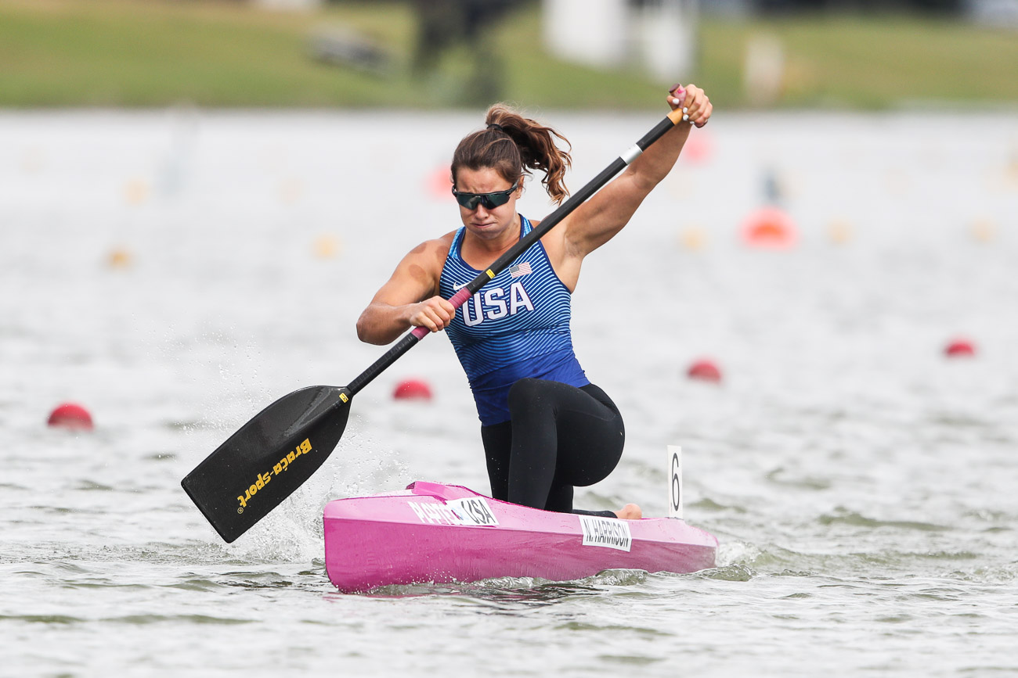

WOMEN’S C1 200 - TOKYO 2020 OLYMPICS
Gold – HARRISON Nevin (USA)
Silver – VINCENT-LAPOINTE Laurence (CAN)
Bronze – LUZAN Liudmyla (UKR)

WOMEN’S C2 500 - TOKYO 2020 OLYMPICS
Gold – XU/SUN (CHN)
Silver – CHETVERIKOVA/LUZAN (UKR)
Bronze – VINCENT/VINCENT-LAPOINTE (CAN)

MEN’S C2 1000 – RECENT OLYMPIC MEDALISTS (changing to 500 in Paris)
2020 – TOKYO, JAPAN
Gold – ENRIQUEZ/MADRIGAL (CUB)
Silver – LIU/ZHENG (CHN)
Bronze – BRENDEL/HECKER (GER)

2016 – RIO, BRAZIL
Gold – BRENDEL/VANDREY (GER)
Silver – QUIROZ DOS SANTOS/DE SOUZA (BRA)
Bronze – IANCHUK/MISHCHUK (UKR)

2012 – LONDON, GREAT BRITAIN
Gold – KRETSCHMER/KUSCHELA (GER)
Silver – BAHDANOVICH/BAHDANOVICH (BLR)
Bronze – KOROVASHKOV/PERVUKHIN (RUS)

2008 – BEIJING, CHINA
Gold – BAHDANOVICH/BAHDANOVICH (BLR)
Silver – GILLE/WYLENZEK (GER)
Bronze – KOZMANN/KISS (HUN)

PARALYMPIC PARACANOE MEDALISTS
MEN’S KL1 200
2020 – TOKYO, JAPAN
Gold – KISS Peter (HUN)
Silver – CARDOSO Luis (BRA)
Bronze – BOULLE Remy (FRA)
2016 – RIO, BRAZIL
Gold – TOKARZ Jakub (POL)
Silver – SUBA Robert (HUN)
Bronze – MARSDEN Ian (GBR)

WOMEN’S KL1 200
2020 – TOKYO, JAPAN
Gold – MUELLER Edina (GER)
Silver – MAZHULA Maryna (UKR)
Bronze – WOLLERMANN Katherinne (CHI)
2016 – RIO, BRAZIL
Gold – CHIPPINGTON Jeanette (GBR)
Silver – MULLER Edina (GER)
Bronze – KUBAS Kamila (POL)

MEN’S KL2 200
2020 - TOKYO, JAPAN
Gold – MCGRATH Curtis (AUS)
Silver – SYNIUK Mykola (UKR)
Bronze – MANCARELLA Federico (ITA)
2016 – RIO, BRAZIL
Gold – MCGRATH Curtis (AUS)
Silver – SWOBODA Markus (AUT)
Bronze – BEIGHTON Nick (GBR)

WOMEN’S KL2 200
2020 – TOKYO, JAPAN
Gold – HENSHAW Charlotte (GBR)
Silver – WIGGS Emma (GBR)
Bronze – VARGA Katalin (HUN)
2016 – RIO, BRAZIL
Gold – WIGGS Emma (GBR)
Silver – LAGUTENKO Nataliia (UKR)
Bronze – SEIPEL Susan (AUS)

MEN’S KL3 200
2020 – TOKYO, JAPAN
Gold – YEMELIANOV Serhii (UKR)
Silver – KRYLOV Leonid (RPC)
Bronze – OLIVER Robert (GBR)
2016 – RIO, BRAZIL
Gold – YEMELIANOV Serhii (UKR)
Silver – KIEREY Tom (GER)
Bronze – de CARVALHO Caio Ribeiro (BRA)

WOMEN’S KL3 200
2020 – TOKYO, JAPAN
Gold – SUGAR Laura (GBR)
Silver – BARBOSA Nelia (FRA)
Bronze – LABERER Felecia (GER)
2016 – RIO, BRAZIL
Gold – DICKENS Anne (GBR)
Silver – REYNOLDS Amanda (AUS)
Bronze – MOREAU Cindy (FRA)

WOMEN’S VL2 200
2020 – TOKYO, JAPAN
Gold – WIGGS Emma (GBR)
Silver – SEIPEL Susan (AUS)
Bronze – CHIPPINGTON Jeanette (GBR)

MEN’S VL2 200
2020 – TOKYO, JAPAN
Gold – RUFINA Fernando (BRA)
Silver – HAXTON Steven (USA)
Bronze – MOURAO Norberto (POR)

MEN’S VL3 200
2020 – TOKYO, JAPAN
Gold – MCGRATH Curtis (AUS)
Silver – VEIRA Giovane (BRA)
Bronze – WOOD Stuart (GBR)
