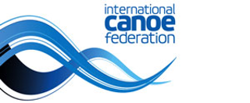
Lee Valley 2023
ICF canoe and extreme slalom world championships
September 19-24
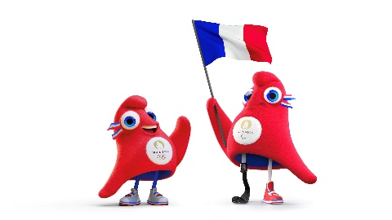
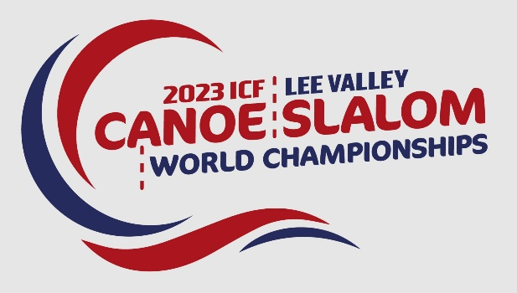
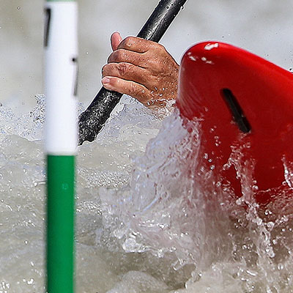
World championships media guide
INTRODUCTION – WORLD TITLES AND THE PATH TO PARIS
The 2023 ICF Canoe Slalom World Championships at Lee Valley is so much more than world titles. It is also the chance for athletes to earn their countries quotas for next year’s Olympic Games in Paris, just as they did on this same course in 2015 ahead of the Rio Games.
The first 13 countries in each of the men’s and women’s canoe competitions, and the first 15 countries in the kayak competitions, will earn quotas. However, if an athlete has already earned a quota in canoe, the same athlete can not also earn a kayak quota.
If an athlete who has earned a canoe quota, also finishes top 15 in kayak, and is the first athlete from their country, then the canoe quota will take precedence.
Don’t forget, in Paris an athlete who has a canoe quota can also contest the kayak, as long as there is no other athlete from their country taking part.
The introduction of kayak cross at the Paris Olympics will also provide new medal and competition opportunities for athletes. Any athlete competing in canoe or kayak, can also enter kayak cross.
Countries who do not earn quotas at Lee Valley will have an additional opportunity to do so at continental qualifiers.
There will be no kayak cross quotas allocated at Lee Valley. A special qualifying event for kayak cross athletes who have not yet earned a quota will be held in Prague in early 2024. There will be three quotas available in Prague for both men and women.

FOR MORE INFORMATION AT THE WORLD CHAMPIONSHIPS
ICF Media and Communications Manager Ross Solly
Phone +41 782 413 114 E-mail ross.solly@canoeicf.com Website canoeicf.com

CANOE SLALOM – A BEGINNER’S GUIDE
The course contains 18–25 gates, each gate comprised of two hanging poles. The downstream gates are coloured green and the upstream gates are red. Competitors must navigate their boat down the course without touching the gate.
As a guide, there will be either six or eight upstream gates.
If the competitor's boat, paddle or body touches either pole of the gate, a time penalty of two seconds is added. If the competitor misses a gate, a 50-second penalty is given. The penalty seconds are then added to the time it took the competitor to complete the course to provide an overall time.
In kayak, the competitor is seated and uses a double-bladed paddle, paddling on alternate sides. In canoe, the competitor uses a single-bladed paddle and sits with legs bent at the knees and tucked under the body, paddling on either the left or right side.
At a world championships athletes have two opportunities to qualify for the semi-finals. On the first qualifying run 30 athletes from men’s kayak and 20 each from women’s kayak and men’s and women’s canoe progress straight to the semi-finals.
The remaining athletes will have a second run, where the top ten finishes in each race will progress to the semis.
The ten fastest semi-finalists will compete in the final, and the ranking and the medallists will be determined based on their finals run alone.
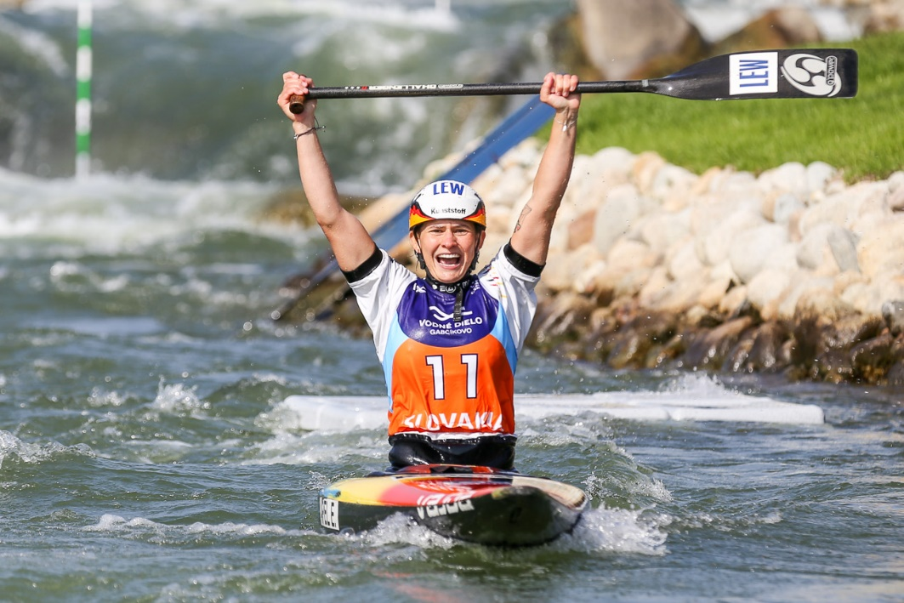
KAYAK CROSS – A BEGINNER’S GUIDE
Kayak cross first appeared on the ICF’s World Cup program in 2015, and since then the growth has been phenomenal. Athlete numbers have been increasing every season, more and more tv networks are showing the races live, and the sport will make its Olympic debut in Paris in 2024.
Kayak cross is a combination of all canoeing’s white water disciplines, with competitors racing in identical plastic creek boats. The excitement begins from the very start, with four competitors sliding off a ramp more than two metres above the water and splashing onto the course as one. From there it’s a race to the first gate buoy, and it really is a case of anything goes as each paddler tries to steal an advantage over their opponents. Athletes need to negotiate both downstream and upstream gate buoys, and contact is allowed – adding to the thrills and spills and excitement for spectators and athletes alike.
Then there’s the compulsory kayak roll. Athletes only have a short window of opportunity to successfully roll their kayaks, and they need to do a complete 360 degree flip under a roll barrier. During their run athletes may be given faults (breaking start, missing a gate or incorrect kayak roll) or a R.A.L (rank as lower) if they have acted dangerously.
One of the major attractions of kayak cross is the diversity of countries taking part. Athletes from regions where canoe slalom is still in its infancy are embracing cross events, and the results have been very exciting.
There will be no Paris 2024 quotas for kayak cross allocated at Lee Valley. These will be decided at a qualifying event in Prague early in 2024.

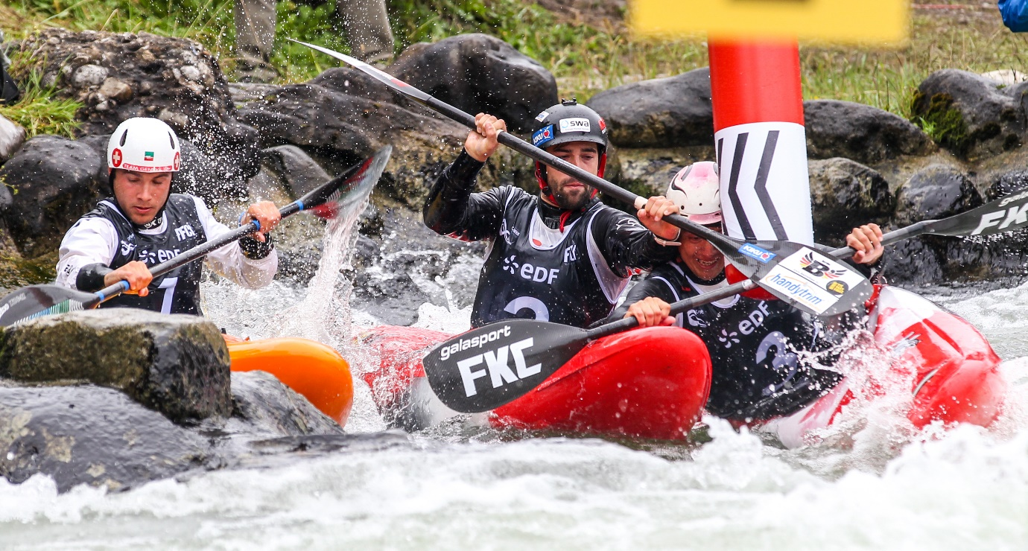

LEE VALLEY CANOE SLALOM AND KAYAK CROSS SCHEDULE
Tuesday September 19
CANOE SLALOM - TEAM EVENTS
10:30:00 | Women's canoe Team
11:00:00 | Men's canoe Team
11:42:30 | Women's kayak Team
12:40:30 | Men's canoe Team
 | Wednesday September 20
CANOE SLALOM - Heats run 1
10:30:00 | Women's canoe - Heats run 1
11:35:00 | Men's canoe - Heats run 1
CANOE SLALOM - Heats run 2
14:00:00 | Women's canoe - Heats run 2
14:44:00 | Men's canoe - Heats run 2
 | Thursday September 21
CANOE SLALOM – Heats run 1
09:00:00 | Women's kayak – heats run 1
10:24:00 | Men's kayak – heats run 1
13:30:00 | Women's kayak – run 2
14:34:00 | Men's kayak – run 2
 | Friday September 22
Canoe Slalom - Semi finals
10:03:00 | Women's canoe - Semi final
11:08:00 | Men's canoe - Semi final
Canoe Slalom - Finals & Medals
13:35:00 | Women's canoe final
14:12:00 | Men's canoe final
 | Saturday September 23
Canoe Slalom - Semi finals
10:03:00 | Women's kayak Semi final
11:08:00 | Men's kayak Semi final
Canoe Slalom - Finals & Medals
13:35:00 | Women's kayak final
14:12:00 | Men's kayak final
Sunday September 24
09:00:00 | Women's kayak cross time trials
09:59:20 | Men’s kayak cross time trials
11:55:00 | Women’s and men’s kayak cross – Heats
KAYAK CROSS - FINAL PHASES
13:34:00 | Women's kayak cross - Quarterfinal
13:52:00 | Men's kayak cross - Quarterfinal
14:10:00 | Women's kayak cross - Semi final
14:19:00 | Men's kayak cross - Semi final
14:30:00 | Women's kayak cross - Final
14:36:00 | Men's kayak cross - Final

For the most up to date schedule, please refer to the ICF website
THE LEE VALLEY VENUE – HOME OF SLALOM AT THE 2012 OLYMPICS
Lee Valley White Water Centre is part of the Lee Valley Regional Park which stretches 26 miles along the leafy banks o the River Lee. The Lee Valley runs through London, Essex and Hertfordshire and includes London 2012 venues, heritage sites and over 10,000 acres of parkland. Just 40 minutes from the centre of London, Lee Valley White Water Centre is not only one of the best canoe slalom venues in the world but perfectly located for visitors to enjoy the capital city.

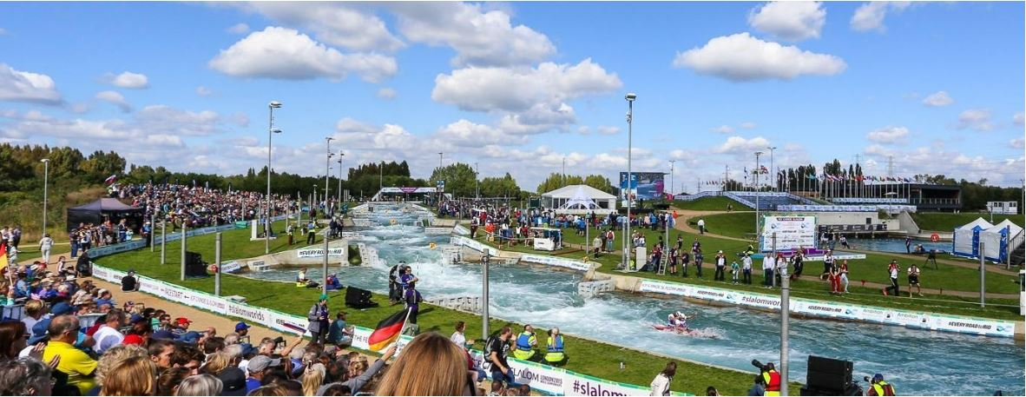
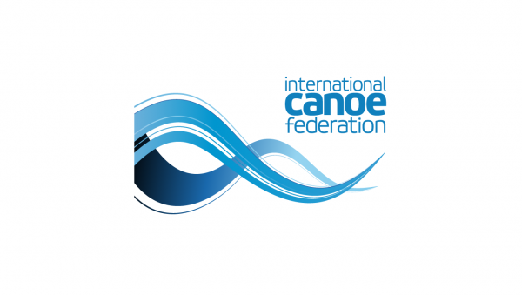
SLALOM AND KAYAK CROSS NUMBERS – AT A GLANCE
  - 302 athletes from 58 federations and five continents will compete in these world championships.

  - The most popular event will be the men’s kayak cross, with 107 athletes from 43 countries entered. 70 competitors from 33 nations have entered the women’s event.

  - There will be 10 world champion titles contested – eight in slalom, two in kayak cross.

  - India will have the biggest team at Lee Valley, with 14 athletes. Several nations will have 12 athletes.

  - Eleven countries will have just one athlete competing at these world championships – Comoros, Cook Islands, Iran, Jamaica, Kenya, Lebanon, Mauritius, Norway, Romania, Singapore and Tunisia. There will also be a refugee athlete.

  - This will be the 43rd ICF canoe slalom world championships. The first titles were held in Geneva, Switzerland, in 1949. It’s just the second world championships in Lee Valley. The first was in 2015.

  - Australia’s Jessica Fox is the most successful female slalom paddler ever, with nine individual world title gold medals and 14 individual medals overall. In Lee Valley she will contest five events – C1, K1, kayak cross and canoe and kayak team events.

  - France is the most successful nation in history, with 60 gold and 156 medals overall. However the combined tally of Germany, East Germany and West Germany is 109 gold and 296 medals.

  - 27 nations have won medals in the 41 previous world championships.

  - Slovakia’s Alexander Slafkovsky and Germany’s Franz Anton have won silver and bronze in men’s C1 at the past two world championships.

  - Since 2009 Slovakia has not finished out of the medals in C1 team events, winning in a row between 2009 and 2019 - each time with Matej Benus, Michal Martikan and Alexander Slafkovsky. In 2021, at home, they finished third, and last year finished second.

  - Czech paddlers have won five of the past eight men’s K1 titles.

  - Five different countries have won the past five men’s K1 team event title. The reigning champions are Germany, who in 2022 won their first team event medal since 2011.

  - Australia has won three and the Czech Republic and Great Britain two of the seven women’s C1 team events. The Czech Republic won in 2021 and 2022 and has never missed a medal.

  - Seven countries have shared the nine medals on offer in the women’s K1 team events at the past three world championships.

  - Australia’s Jessica Fox has won four of the 11 women’s C1 world titles contested. She has only missed the medals three times – in Bratislava in 2011 and 2021, and in Pau in 2017. Her last gold was in 2018.

  - Germany has won the past three women’s C1 world titles.

  - Germany’s Ricarda Funk has won the past two K1 world titles, while Jessica Fox has won three of the past seven titles. She also won silver in 2019.

  - Four different nations have won the five women’s extreme slalom world titles contested. Jessica Fox won the title in 2021 and 2022.

  - Four different nations have won the four men’s extreme slalom world titles contested. Great Britain ‘s Joe Clarke won in 2021 and 2022.

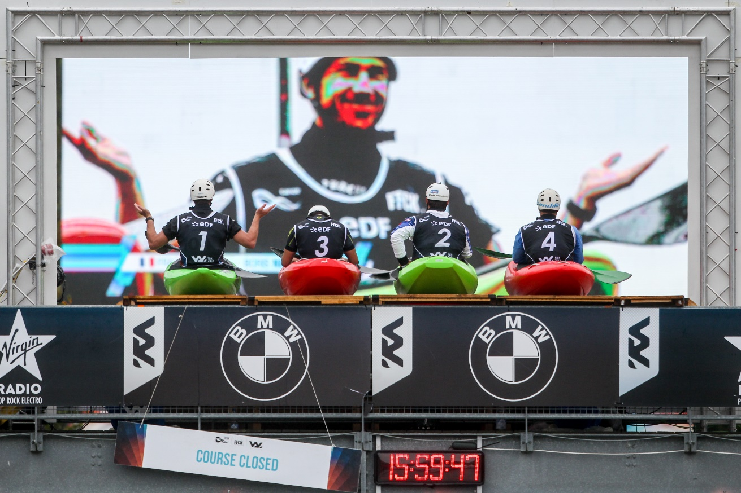
ATHLETES TO WATCH
MEN’S KAYAK
PRSKAVEC, Jiri (CZE) – Gold medalist from Tokyo, bronze medalist from Rio Olympics, he won the world championships in 2015 and 2019 – both Olympic selection events. He has won two world cups this year.
CLARKE, Joe (GBR) – Gold medalist from Rio 2016 who missed selection for Tokyo and is determined to climb back to the top. Won silver at most recent world cup.
KAUZER, Peter (SLO) – Won silver in Rio and was world champion in 2009 and 2011. Tokyo was his fourth Olympic Games. He won gold at the most recent world cup.
AIGNER, Hannes (GER) – won the bronze medal in Tokyo and in London in 2012 and was world champion in 2018.
GRIGAR, Jakub (SVK) – Won silver in Tokyo, finished fifth in Rio, a two-time U23 and two-time junior world champion.
PRINDIS, Vit (CZE) – The form paddler of 2021, crowned overall world cup winner and is leading this year’s world cup standings after two silver and a bronze.
DE GENNARO, Giovanni (ITA) – Two-time Olympian who won silver at 2022 world championships.

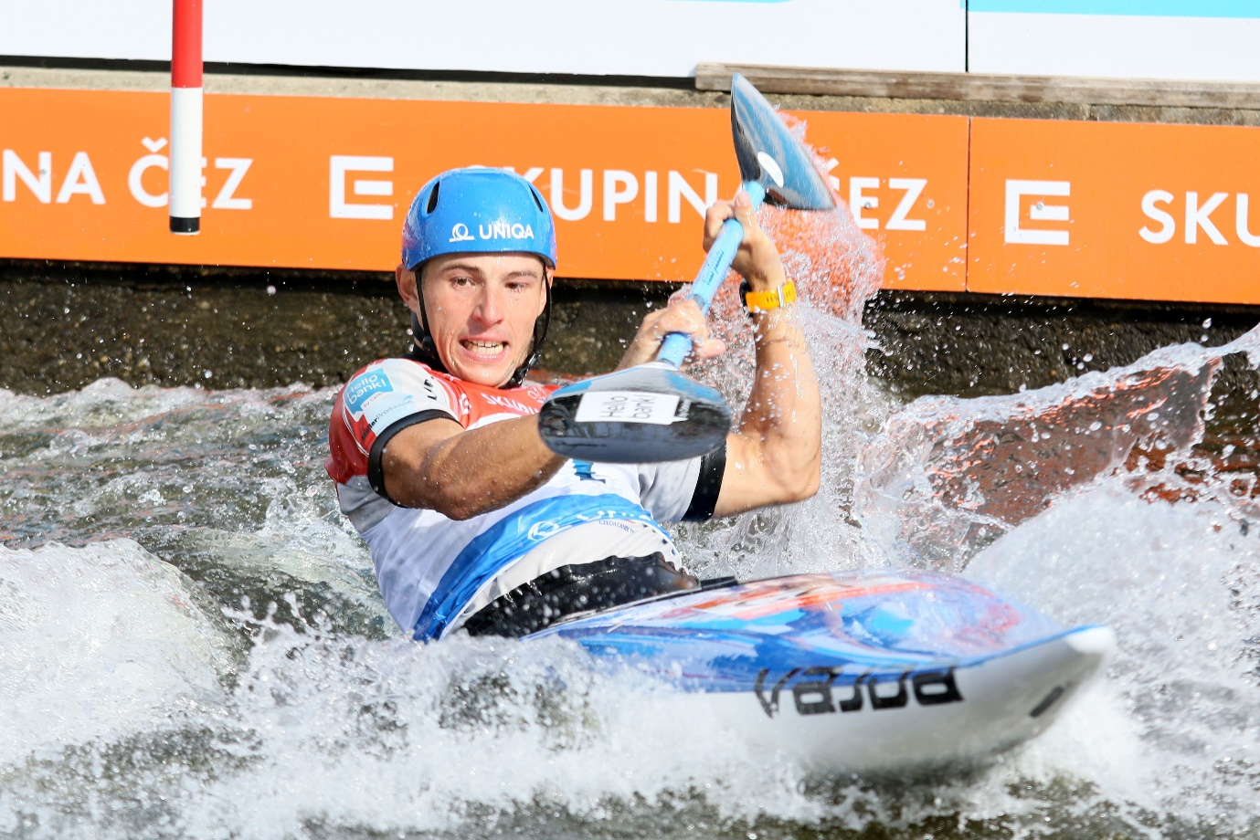

WOMEN’S KAYAK
FOX, Jessica (AUS) – Olympic bronze medalist in Tokyo and Rio, silver medalist in London, overall world cup winner 2022, leading this year, three-time ICF K1 world champion. Two gold and one silver so far this season.
FUNK, Ricarda (GER) – Gold medalist from Tokyo, world champion in 2021 and 2022, was the overall ICF world cup winner in 2016 and 2017.
TERCELJ, Eva (SLO) – ICF world champion from 2019, competed at the Tokyo and London Olympics
HORN, Stefanie (ITA) – Two-time Olympian, has won a silver and a bronze at world cups this season.
LILIK, Elena (GER) – Silver medal at 2021 world titles, bronze medal last year. Has a world cup gold and bronze medal this season.
FRANKLIN, Mallory (GBR) – Silver medalist from 2018 world championships, won bronze at Prague world cup this year.
ZWOLINSKA, Klaudia (POL) – Finished fifth at the Tokyo Olympics, where two gate touches robbed her of a podium finish. Has two world cup fourth placings this year.
LEIBFARTH, Evy (USA) – American teenager made her Olympic debut, won the K1 junior world title on the eve of the Tokyo Olympics, and the U23 world title this year.
SATILA, Ana (BRA) – made her Olympic debut as a teenager in London, Tokyo was her third Olympics.
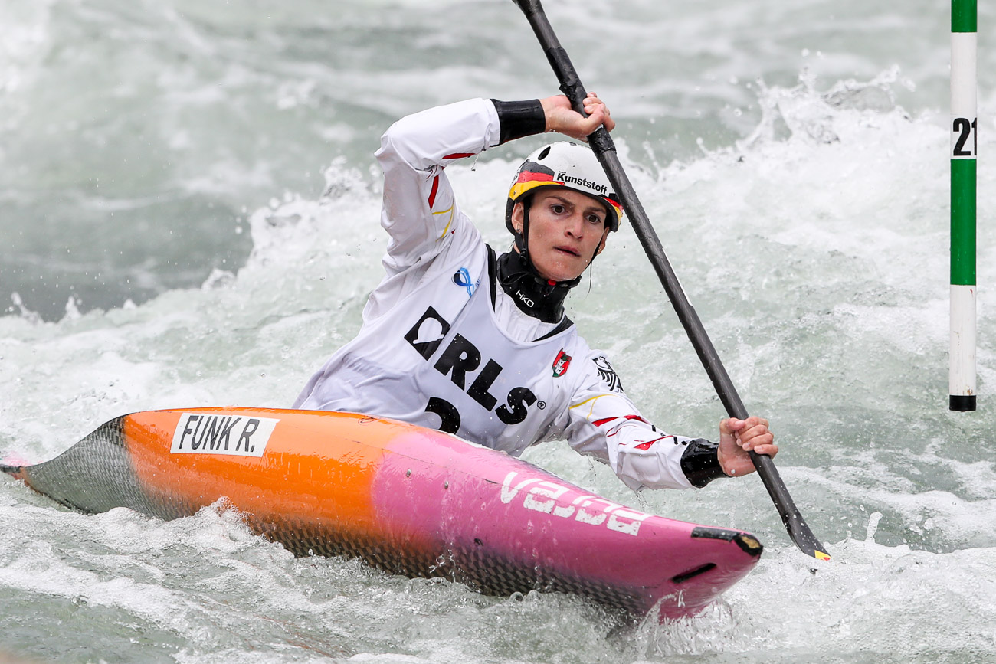
MEN’S CANOE
SAVSEK, Benjamin (SLO) – Tokyo Olympic gold medalist, finished 6th in 2016 and 8th in 2012. ICF world champion from 2017, won gold at Prague world cup this season.
BENUS, Matej (SVK) – Silver medalist at the Rio Olympics, he is a three-time overall ICF world cup winner, the latest in 2019. Leading world cup standings this season after two silver medals.
TASIADIS, Sideris (GER) – Bronze medalist in Tokyo, silver medalist at the London Olympics, finished fifth in Rio in 2016. Reigning world champion, won world cup gold in Augsburg this year.
ROHAN, Lukas (CZE) – Silver medalist at Tokyo, silver medalist at 2020 European championships.
BOZIC, Luka (SLO)– Gold and silver at his last two world cup events and second in current overall season standings
ANTON, Franz (GER) – 2018 ICF world champion, missed out on selection for Tokyo Olympics. Won bronze at past two world championships.
SLAFKOVSKY, Alexander (SVK) – In possibly his last world championshp appearance, looking to break through for first world title after three silver medals. Won world cup gold in Tacen.
BURGESS, Adam (GBR) – Finished fourth at Tokyo Olympics, 2018 European silver medalist and former U23 world champion
CHALOUPKA Vaclav (CZE) – World champion from 2021.

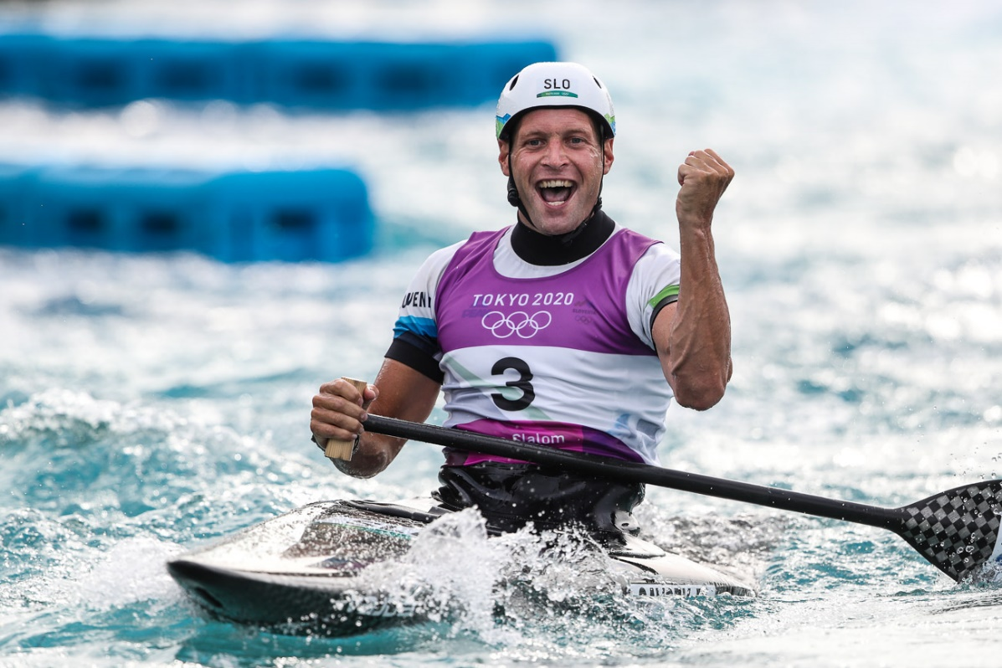
WOMEN’S CANOE
FOX, Jessica (AUS) – Has dominated this event, winning Tokyo Olympic gold and the ICF world title on four occasions. Finished second at the 2019 and 2022 world titles. Has won three of the four world cup titles this year.
HERZOG, Andrea (GER) –ICF C1 world champion from last year and 2019, won bronze in Tokyo and silver at the most recent ICF world cup.
FRANKLIN, Mallory (GBR) – Tokyo Olympic silver medalist, 2017 ICF world champion and 2019 European champion. Has also won three world championship silver medals, and won bronze at last year’s world titles.
FISEROVA, Tereza (CZE) – 2021 overall world cup winner, sixth at Tokyo Olympics, silver medal at 2017 world championship, bronze in 2018, three-time silver medalist at European championships, including in 2021. Two fourth placings this year.
LILIK, Elena (GER) – World champion from Bratislava 2021. Won gold in Tacen and bronze in Augsburg this season.
US, Viktoriia (UKR) – Two-time Olympian, won silver in Tacen and sits third overall this season.
LEIBFARTH, Evy (USA) – 19-year-old was the youngest canoe slalom competitor in Tokyo. Won bronze at this year’s U23 world titles.

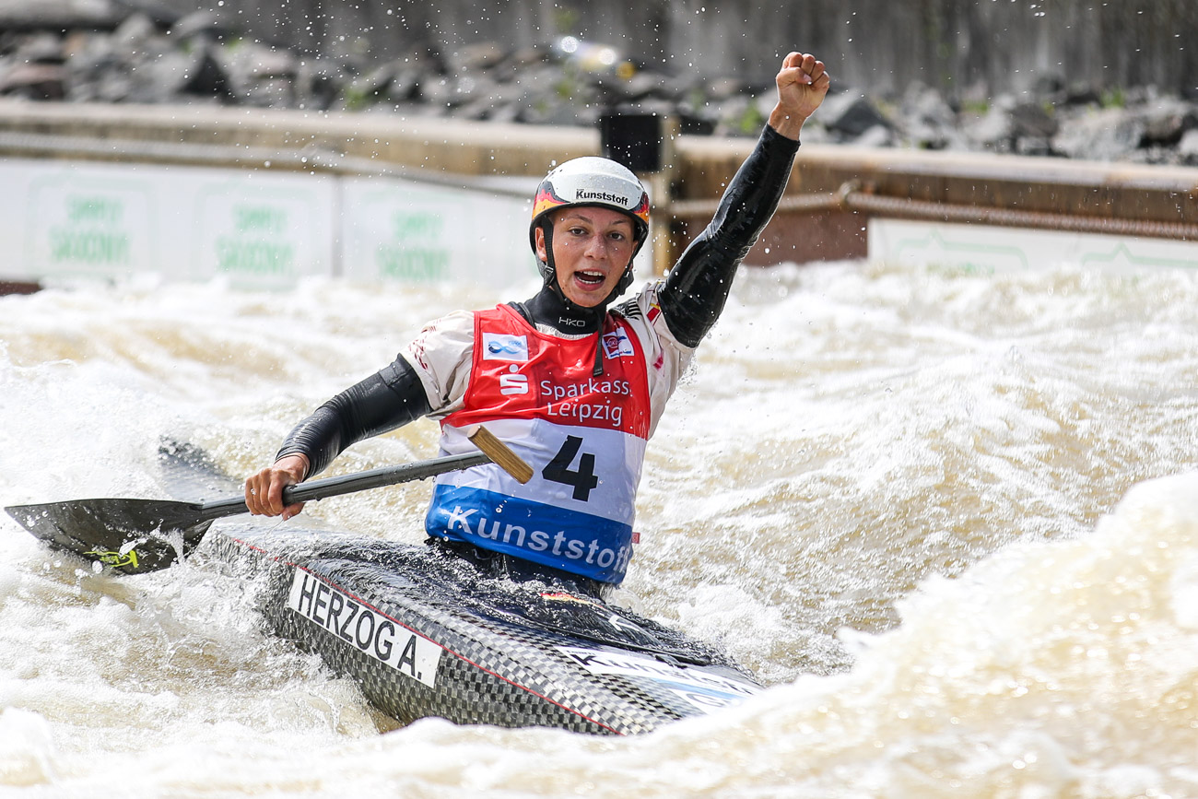

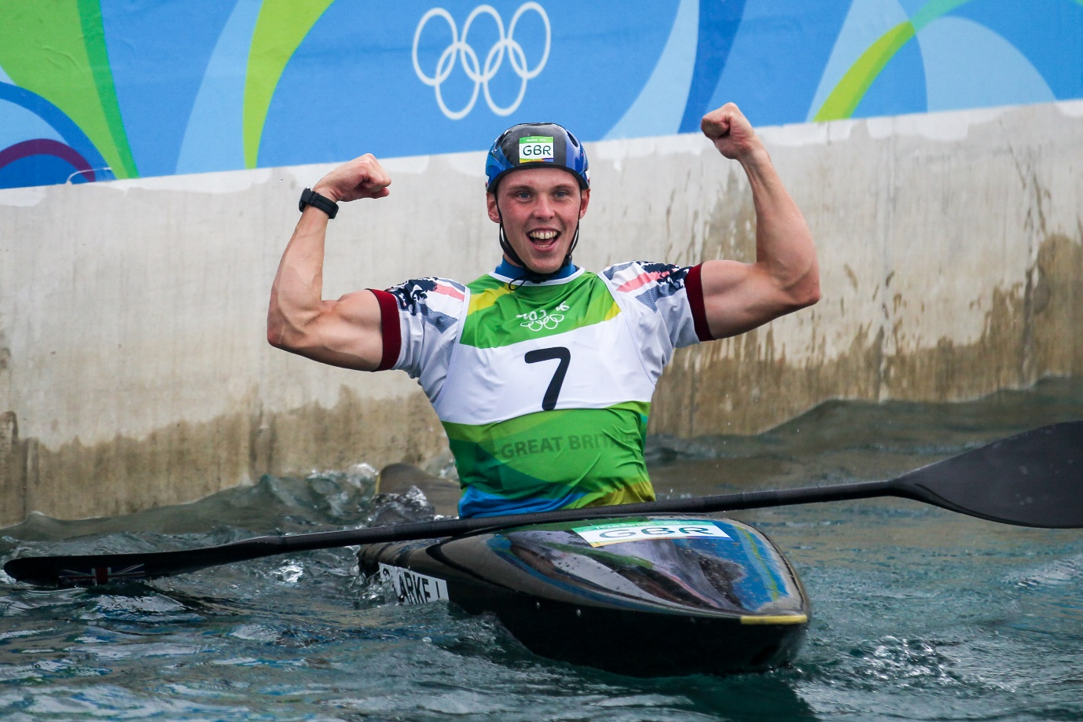
MEN’S K1
RECENT OLYMPIC MEDALISTS
2020 – TOKYO, JAPAN
Gold – PRSKAVEC, Jiri (CZE)
Silver – GRIGAR Jakub (SVK)
Bronze – AIGNER Hannes (GER)
2016 – RIO, BRAZIL
Gold – CLARKE Joseph (GBR)
Silver – KAUZER Peter (SLO)
Bronze – PRSKAVEC Jiri (CZE)

2012 – LONDON, GREAT BRITAIN
Gold – MOLMENTI Daniele (ITA)
Silver – HRADILEK Vavrinec (CZE)
Bronze – AIGNER Hannes (GER)
MEN’S K1 – RECENT WORLD CHAMPIONS
2022 – AUGSBURG, GERMANY
Gold – PRINDIS, Vit (CZE)
Silver – DE GENNARO Giovanni (ITA)
Bronze – NEVEU Boris (FRA)

2021 – BRATISLAVA, SLOVAKIA
Gold – NEVEU Boris (FRA)
Silver – BEDA Marcello (ITA)
Bronze – CRESPO Joan (ESP)

2019 – LA SEU, SPAIN
Gold – PRSKAVEC Jiri (CZE)
Silver – LLORENTE David (ESP)
Bronze – CRESPO Joan (ESP)

2018 – RIO, BRAZIL
Gold – AIGNER Hannes (GER)
Silver – PRSKAVEC Jiri (CZE)
Bronze – EIGEL Pavel (RUS)

2017 – PAU, FRANCE
Gold – TUNKA Ondrej (CZE)
Silver – PRINDIS Vit (CZE)
Bronze – KAUZER Peter (SLO)

2015 – LEE VALLEY, UNITED KINGDOM
Gold – PRSKAVEC Jiri (CZE)
Silver – POLACZYK Mateusz (POL)
Bronze – SMOLEN Michal (USA)

2014 – DEEP CREEK, USA
Gold – NEVEU Boris (FRA)
Silver – COMBOT Sebastien (FRA)
Bronze – BIAZIZZO Mathieu (FRA)

2013 – PRAGUE, CZECH REPUBLIC
Gold – HRADILEK Vavrinec (CZE)
Silver – PRSKAVEC Jiri (CZE)
Bronze – POLACZYK Mateusz (POL)

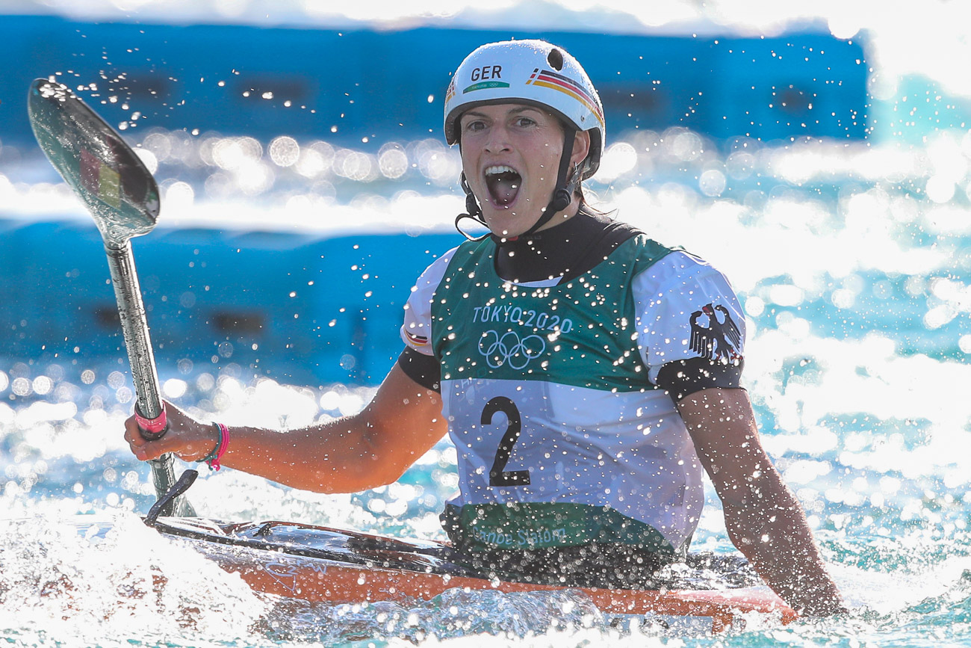
WOMEN’S K1
RECENT OLYMPIC MEDALISTS
2020 – TOKYO, JAPAN
Gold – FUNK Ricarda (GER)
Silver – CHOURRAUT Maialen (ESP)
Bronze – FOX Jessica (AUS)
2016 – RIO, BRAZIL
Gold – CHOURRAUT Maialen (ESP)
Silver – JONES Luuka (NZL)
Bronze – FOX Jessica (AUS)

2012 LONDON, UNITED KINGDOM
Gold – FER Emilie (FRA)
Silver – FOX Jessica (AUS)
Bronze – CHOURRAUT Maialen (ESP)

WOMEN’S K1 – RECENT WORLD CHAMPIONS
2022 – AUGSBURG, GERMANY
Gold – FUNK Ricarda (GER)
Silver – FOX Jessica (AUS)
Bronze – LILIK Elena (GER)

2021 – BRATISLAVA, SLOVAKIA
Gold – FUNK Ricarda (GER)
Silver – APEL Elena (GER)
Bronze – WOODS Kimberley (GBR)

2019 – LA SEU, SPAIN
Gold – TERCELJ Eva (SLO)
Silver – FOX Jessica (AUS)
Bronze – JONES Luuka (NZL)

2018 – RIO, BRAZIL
Gold – FOX Jessica (AUS)
Silver – FRANKLIN Mallory (GBR)
Bronze – FUNK Ricarda (GER)

2017 – PAU, FRANCE
Gold – FOX Jessica (AUS)
Silver – DUKATOVA Jana (SVK)
Bronze – FUNK Ricarda (GER)

2015 – LEE VALLEY, UNITED KINGDOM
Gold – KUDEJOVA Katerina (CZE)
Silver – FUNK Ricarda (GER)
Bronze – PFEIFER Melanie (GER)

2014 – DEEP CREEK, USA
Gold – FOX Jessica (AUS)
Silver – PENNIE Fiona (GBR)
Bronze – PFEIFER Melanie (GER)

2013 – PRAGUE, CZECH REPUBLIC
Gold – FER Emilie (FRA)
Silver – NEWMAN Nouria (FRA)
Bronze – SCHORNBERG Jasmin (GER)

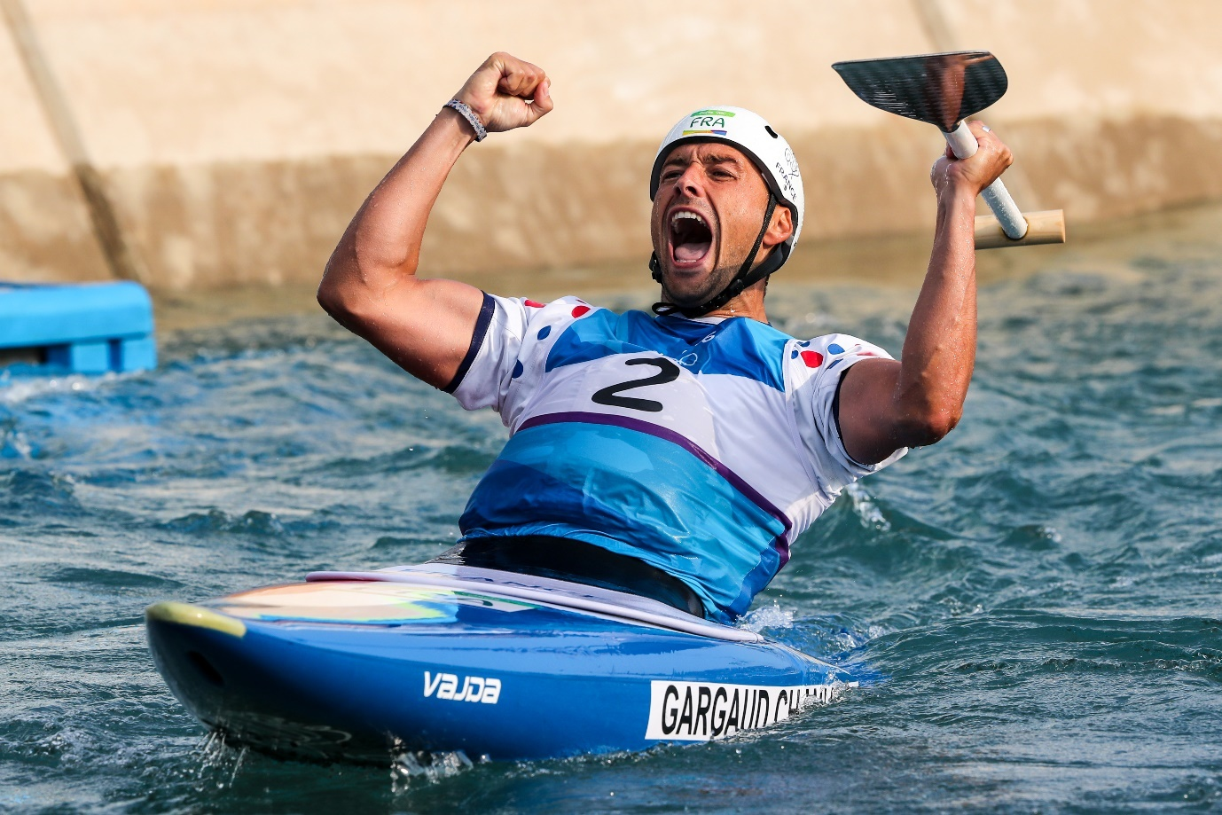
MEN’S C1
RECENT OLYMPIC MEDALISTS
2020 – TOKYO, JAPAN
Gold – SAVSEK Benjamin (SLO)
Silver – ROHAN Lukas (CZE)
Bronze – TASIADIS Sideris (GER)
2016 – RIO, BRAZIL
Gold – GARGAUD CHANUT Denis (FRA)
Silver – BENUS Matej (SVK)
Bronze – HANEDA Takuya (JPN)

2012 – LONDON, GREAT BRITAIN
Gold – ESTANGUET Tony (FRA)
Silver – TASIADIS Sideris (GER)
Bronze – MARTIKAN Michal (SVK)
MEN’S C1 – RECENT WORLD CHAMPIONS
2022 – AUGSBURG, GERMANY
Gold – TASIADIS Sideris (GER)
Silver – SLAFKOVSKY Alexander (SVK)
Bronze – ANTON Franz (GER)

2021 – BRATISLAVA, SLOVAKIA
Gold – CHALOUPKA Vaclav (CZE)
Silver – SLAFKOVSKY Alexander (SVK)
Bronze – ANTON Franz (GER)

2019 – LA SEU, SPAIN
Gold – JOLY Cedric (FRA)
Silver – ELOSEGI Ander (ESP)
Bronze – BOZIC Luka (SLO)

2018 – RIO, BRAZIL
Gold – ANTON Franz (GER)
Silver – WESTLEY Ryan (GBR)
Bronze – TASIADIS Sideris (GER)

2017 – PAU, FRANCE
Gold – SAVSEK Benjamin (SLO)
Silver – SLAFKOVSKY Alexander (SVK)
Bronze – MARTIKAN Michal (SVK)

2015 – LEE VALLEY, UNITED KINGDOM
Gold – FLORENCE David (GBR)
Silver – SAVSEK Benjamin (SLO)
Bronze – WESTLEY Ryan (GBR)

2014 – DEEP CREEK, USA
Gold – LEFEVRE Fabien (USA)
Silver – SAVSEK Benjamin (SLO)
Bronze – ANTON Franz (GER)

2013 – PRAGUE, CZECH REPUBLIC
Gold – FLORENCE David (GBR)
Silver – SLAFKOVSKY Alexander (SVK)
Bronze – SAVSEK Benjamin (SLO)
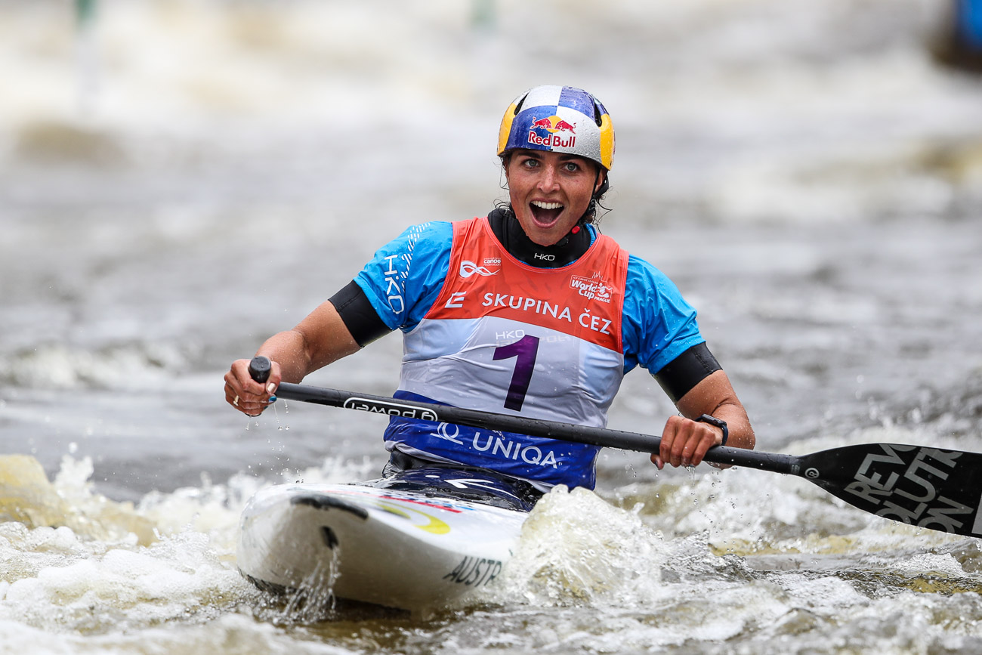WOMEN’S C1 – RECENT OLYMPIC MEDALISTS
2020 – TOKYO, JAPAN
Gold – FOX Jessica (AUS)
Silver – FRANKLIN Mallory (GBR)
Bronze – HERZOG Andrea (GER)

WOMEN’S C1 – RECENT WORLD CHAMPIONS
2022 – AUGSBURG, GERMANY
Gold – HERZOG Andrea (GER)
Silver – FOX Jessica (AUS)
Bronze – FRANKLIN Mallory (GBR)

2021 – BRATISLAVA, SLOVAKIA
Gold – APEL Elena (GER)
Silver – FRANKLIN Mallory (GBR)
Bronze – SATKOVA Gabriela (CZE)

2019 – LA SEU, SPAIN
Gold – HERZOG Andrea (GER)
Silver – FOX Jessica (AUS)
Bronze – WERATSCHNIG Nadine (AUT)

2018 – RIO, BRAZIL
Gold – FOX Jessica (AUS)
Silver – FRANKLIN Mallory (GBR)
Bronze – FISEROVA Tereza (CZE)

2017 – PAU, FRANCE
Gold – FRANKLIN Mallory (GBR)
Silver – FISEROVA Tereza (CZE)
Bronze – SATILA Ana (BRA)

2015 – LEE VALLEY, UNITED KINGDOM
Gold – FOX Jessica (AUS)
Silver – HOSKOVA Katerina (CZE)
Bronze – VILLARRUBLA Nuria (ESP)

2014 – DEEP CREEK, USA
Gold – FOX Jessica (AUS)
Silver – FRANKLIN Mallory (GBR)
Bronze – REBOURS Oriane (FRA)

2013 – PRAGUE, CZECH REPUBLIC
Gold – FOX Jessica (AUS)
Silver – FRANKLIN Mallory (GBR)
Bronze – LOIR Caroline (FRA)

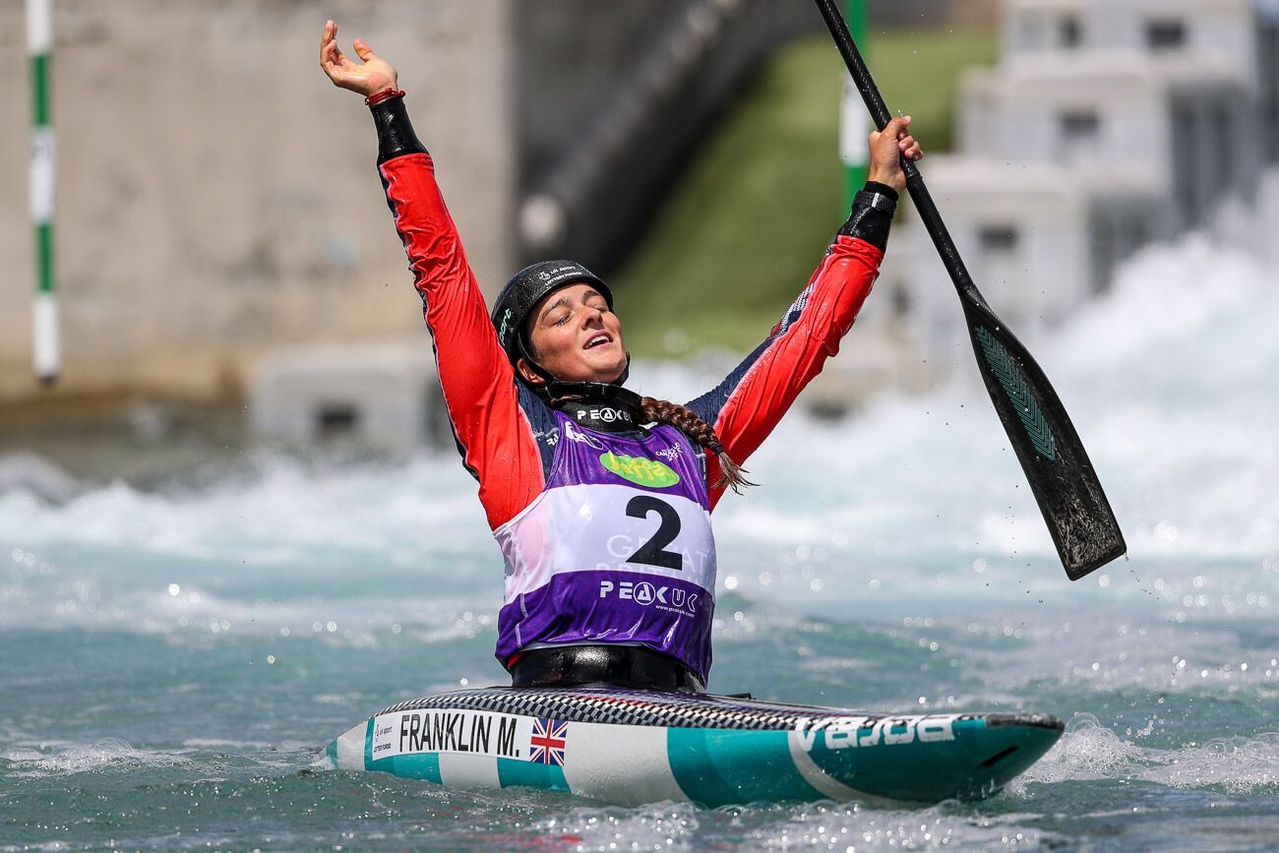

MEN’S EXTREME SLALOM
RECENT WORLD CHAMPIONS
2022 – AUGSBURG, Germany
Gold – CLARKE, Joseph (GBR)
Silver – DELASSUS Anatole (FRA)
Bronze – HENGST Stefan (GER)

2021 – BRATILAVA, SLOVAKIA
Gold – CLARKE, Joseph (GBR)
Silver – BUTCHER Finn (NZL)
Bronze – LEITNER Mario (AUT)

2019 – PRAGUE, CZECH REPUBLIC
Gold – HENGST, Stefan (GER)
Silver – GUBENKO, Nikita (RUS)
Bronze – GONCALVES, Pedro (BRA)

2018 – RIO, BRAZIL
Gold – DE DIONIGI, Christian (ITA)
Silver – NEVEU Boris (FRA)
Bronze – BERSINGER Thomas (ARG)

2017 – PAU, FRANCE
Gold – HRADILEK, Vavrinec (CZE)
Silver – NEVEU, Boris (FRA)
Bronze – DAWSON, Mike (NZL)

WOMEN’S EXTREME SLALOM
RECENT WORLD CHAMPIONS
2022 – AUGSBURG. GERMANY
Gold – FOX, Jessica (AUS)
Silver – WOODS Kimberley (GBR)
Bronze – DORIA VILARRUBLA Monica (AND)

2021 – BRATISLAVA, SLOVAKIA
Gold – FOX, Jessica (AUS)
Silver – LILAK Elena (GER)
Bronze – LEIBFARTH Evy (USA)

2019 – PRAGUE, CZECH REEPUBLIC
Gold – VOJTOVA, Veronika (CZE)
Silver – MUKHGALEEVA, Polina (RUS)
Bronze – TROMPETER, Caroline (GER)

2018 – RIO, BRAZIL
Gold – SATILA, Ana (BRA)
Silver – WEGMAN, Martina (NED)
Bronze – MUKHGALEEVA, Polina (RUS)

2017 – PAU, FRANCE
Gold – TROMPETER, Caroline (GER)
Silver – SATILA, Ana (BRA)
Bronze – HILGERTOVA, Amalie (CZE)

